**PROJECT REPORT**

**ON**

**MOBILESHOP-E**

**By**

**DISHANT GAJERA (196330307025)**

**DHRUV PALIYA (196330307054)**

**KAXAK DOBARIYA (196330307512)**

**YUVRAJSINH RANA (196330307548)**

**MANAV SHAH (196330307556)**



**DEPARTMENT OF COMPUTER ENGINEERING**

L.J.POLYTECHNIC, AHMEDABAD

2021-2022

**DEPARTMENT OF COMPUTER ENGINEERING**

L.J.POLYTECHNIC, AHMEDABAD

2021-2022

**CERTIFICATE**

**Date: ___/___/____**

This is to certify that **Mr. *DISHANT GAJERA*, Mr. *DHRUV PALIYA,* Mr. KAXAK DOBARIYA, Mr. *YUVRAJSINH RANA and* Mr. MANAV SHAH** from LJ POLYTECHNIC having Enrollment No. ***1963303075025*, *196330307054, 196330307512, 196330307548 and 196330307556*** have completed project documentation and development on the problem definition of semester VI during the academic year 2021-22 having Title ***MOBILESHOP-E*** in a group consisting of 5 members.

**Institute Guide**  **Head of the Department**

**ACKNOWLEDGEMENT**

This website is because of the dedication and encouragement of many individuals. We would like to thank our guide, the books which were very informative and the websites from where we got useful help in accomplishing the task of making this website. We are thankful to our faculties and those people who helped us, inspired us, given moral support to us and encouraged us and helped us in various ways to accomplish the task.

**DISHANT GAJERA (196330307025)**

**DHRUV PALIYA (196330307054)**

**KAXAK DOBARIYA (196330307512)**

**YUVRAJSINH RANA (196330307548)**

**MANAV SHAH (196330307556)**

**Table of Contents**

**ABSTRACT 1**

**Chapter 1 Introduction 2**

1.1 Need for the New system 2

1.2 Detailed Problem Definition 2

1.3 Viability of the System 3

1.4 Presently Available Systems for the same 3

1.5 Future Prospects 4

**Chapter 2 Analysis 5**

2.1 Requirement Analysis 5

2.2 Project Model 6

2.3 Schedule Representation 7

2.4 Feasibility Study 8

**Chapter 3 Design 10**

3.1 Data Flow Diagram 10

3.2 ER-Diagram 15

**Chapter 4 System Modeling 18**

4.1 Data dictionary 18

4.1 Database Designing 19

**Chapter 5 Technical Specification 29**

5.1 Hardware Specification 29

5.1.1 RAM 29

5.1.2 Hard Drive Storage needed 29

5.1.3 Other Hardware requirement 29

5.2 Platform 29

5.2.1 Supported Operating System 29

5.2.2 Programming Server 29

5.2.3 Framework (if any) 29

5.3 Programming Languages used 29

5.3.1 Markup Language 29

5.3.2 Programming Language 29

5.3.3 Scripting Language (If any) 29

5.4 Technical Specification 29

5.4.1 Front-End 29

5.4.2 Back-End 29

5.4.3 IDE 29

5.4.4 UML Tools 29

5.4.5 SRS Tools 29

5.5 Design Layout 30

**Chapter 6 Testing 74**

6.1Testing methods 74

6.1.1 Black box testing 74

6.1.2 White box testing 76

**Conclusion** 79

**Bibliography** 80

**Table INDEX**

**1 Schedule Representation 8**

**2 Data Flow Diagram Symbols 10**

**3 ER-Diagram Symbols 16**

**4 admin_master 19**

**5 shopkeeper_master 20**

**6 customer_master 21**

**7 brand_master 22**

**8 product_master 23**

**9 review_master 24**

**10 cart_master 25**

**11 cart_archive_master 26**

**12 order_master 27**

**13 order_archive_master 28**

**14 payment_master 29**

**Figure INDEX**

**1 Interative waterfall model 6**

**2 DFD level 0 11**

**3 Admin level 1 12**

**4 Shopkeeper level 1 13**

**5 Customer level 1 14**

**6 ER diagram 17**

**7 Design layout 30**

**8 Black box testing 74**

**9 White box testing 76**

**10 State transition diagram 78**

**ABSTRACT**

*MOBILESHOP-E is process of doing business through computer networks.   
A person sitting on his chair in front of a computer can access all the facilities of internet to shop for desired products. Unlike traditional way that's administered physically with effort of an individual to walk into the shop and buy products. E-commerce websites like this has made it easier for an individual to reduce physical work and save time. But the very fact that has hindered the growth of e-commerce websites is security reasons. The goal of creating this website is to provide a secure environment to prevent frauds like misuse of private data, phishing attacks etc... . The main advantage of e-commerce website over traditional way is that the user can browse products, compare prices and order products all by sitting home on their PC. The user-friendly design helps the users to accomplish their task without a problem. Attempts are made to keep the website simple and understandable.*

**CHAPTER 1**

**INTRODUCTION**

**1.1 Need of the system**

* There are large numbers of commercial Online Electronic Shopping websites offering large number of products tailored to meet the shopping interests of large number of customers. These online marketplaces have thousands of products listed under various categories.

**1.2 Detailed problem definition**

* The basic problems with the existing systems are the non-interactive environment they provide to the users.
* The use of traditional user interfaces which make continuous post backs to the server; each post back makes a call to the server, gets the response and then refreshes the entire web form to display the result.
* A search engine that would display the results without allowing the users to further filter the results based on various parameters.
* Use of traditional and non-user-friendly interfaces that are hard to use.

**Solution:**

* The motive of this online electronic Shopping Web Website is to allow the user use the search tool and create different combinatorial search criterion to perform exhaustive search.
* Making the website AJAX enabled gets rid of these unnecessary delays letting the user to perform exhaustive search. The users of this website can easily feel the difference between the Ajax empowered user interfaces vs. traditional user interfaces.
* Provide Interactive interface through which a user can interact with different areas of application easily.
* A search engine that provides an easy and convenient way to search for products specific to their needs. The search engine would list a set of products based on the search term and the user can further filter the list based on various parameters.

**1.3 Viability of the system:**

* This website not only provides all the required information about the available electronic products and the requirements to apply for it, but it also regularly provides students the updates and news, ability to read and write reviews about the electronic products, provides special help form experts etc. making it a complete website which provides the users a delightful experience.

**1.4 Currently available system:**

* RELIANCE DIGITAL
* U BUY
* Tata CLiQ
* SNAPDEAL
* CROMA

**1.5 Future prospects**

* We also aim to provide a forum where open discussion can be held amongst the customer.
* We can also provide Laptop, Desktop, TV, AC, Refrigerator, and other Many products to add in our website.

**CHAPTER-2**

**ANALYSIS**

**2.1 Requirement analysis:**

* Users can be classified into two types based on their knowledge of the products that suit their needs. They can be classified as users who know about the product that would satisfy their needs and users who have to figure out the product that would satisfy their needs. Users who know about the product should be able to find the product easily with the click of a button. Such users can search for the product by using the product name as the search term. Users who have to figure out the product that would satisfy their needs could use a search term to find a list of products and then should be able to filter the results based on various parameters like product type, manufacturer, price range, platform supported etc.
* The users should be able to view the complete specification of the product and various images at different Zoom levels. The user should be able to read the reviews written by other users and also able to write their own reviews about the product.

**2.2 Project model:**

* In the Iterative model, iterative process starts with a simple implementation of a small set of the software requirements and iteratively enhances the evolving versions until the complete system is implemented and ready to be deployed.
* An iterative life cycle model does not attempt to start with a full specification of requirements.
* Instead, development begins by specifying and implementing just part of the software, which is then reviewed to identify further requirements.
* This process is then repeated, producing a new version of the software at the end of each iteration of the model.

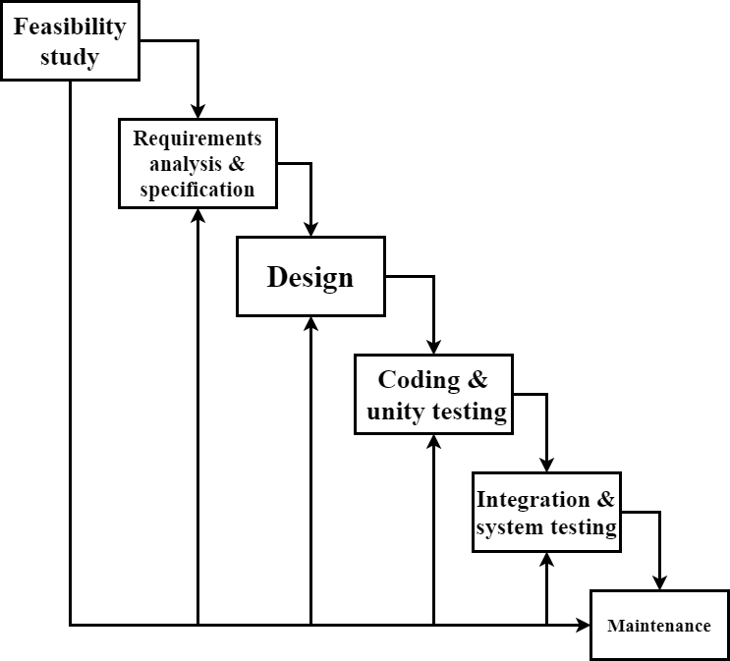

**[Figure 1: Iterative Waterfall Model]**

**Advantages:**

* It is more cost effective to change the scope or requirements in   
   Iterative model.
* Parallel development can be planned.
* Testing and debugging during smaller iteration is easy.
* Risks are identified and resolved during iteration; and each   
   iteration is an easily managed.

**Disadvantages:**

* More resources may be required.
* Highly skilled resources are required for skill analysis.
* Project progress is highly dependent upon the risk analysis phase.

**2.3 Schedule representation**

Generalized project scheduling tools and technique can be applied with little modification to software projects.

Program evolution and review techniques (PERT) and critical path method (CPM) are two project scheduling method that can be applied to software development. Both techniques are driven by information already developed in earlier project planning activities:

* Estimate of effort.
* A decomposition of the product function.
* The selection of appropriate task set.
* Decomposition of tasks.

**[Table 1: Schedule Representation]**

|  |  |  |
| --- | --- | --- |
| ACTIVITY | DATE START | DATE FINISH |
| Requirement Analysis |  |  |
| System Analysis |  |  |
| System Design |  |  |
| System Coding |  |  |
| Testing and Integration |  |  |

**2.4 Feasibility study**

**2.4.1 Technical Feasibility**

This assessment is based on an outline design of system requirements, to determine whether the company has the technical expertise to handle completion of the project. When writing a feasibility report, the following should be taken to consideration:

* A brief description of the business to assess more possible

factors which could affect the study.

* The part of the business being examined.
* The human and economic factor.
* The possible solutions to the problem.
* This system include firebase to store the information of

user in the database easily.

**2.4.2 Economic Feasibility:**

In economic feasibility, cost benefit analysis is done in which expected costs and benefits are evaluated. Economic analysis is used for evaluating the effectiveness of the proposed system.

This system is made on low budget and it will allow its user to use various features at no cost.

**2.4.3 Operational Feasibility:**

A feasibility study is an assessment of the practicality of a proposed project or system. A feasibility study aims to objectively and rationally uncover the strengths and weaknesses of an existing business. In its simplest terms, the two criteria to judge feasibility are cost required and value to be attained.

The system is very efficient as the users can easily find what they are looking for and it would not take more than few minutes for them to find the exact device that they are looking for.

The system provides suggestions which help user to select the best suitable device for them.

**CHAPTER-3**

**DESIGN**

**3.1 Data flow diagram**

DFD (data flow diagram) is also known as bubble chart or data flow graph. DFD’s are very useful in understanding the system and can be effectively used during analysis. It shows flow of data through a system visually. The DFD is a hierarchical graphical model of a system the different processing activities or functions that the system performs and the data interchange among these functions. It views a system as a function that transforms the inputs into desired output. Each function is considered as a process that consumes some input data and produces some output data. Function model can be represented using DFD.

**[Table 2: data flow diagram symbols]**

|  |  |
| --- | --- |
| **Symbols** | **Description** |
|  | **Entity:** Entities are external to the system which interacts by inputting the data. |
|  | **System:** It shows the system name. |
|  | **Process:** It shows the part of the system that transforms into outputs. |
|  | **Data Flow:** It passes the data from one part to another. |
|  | **Data store:** data store is represented by two databases. |

1. DFD level 0:

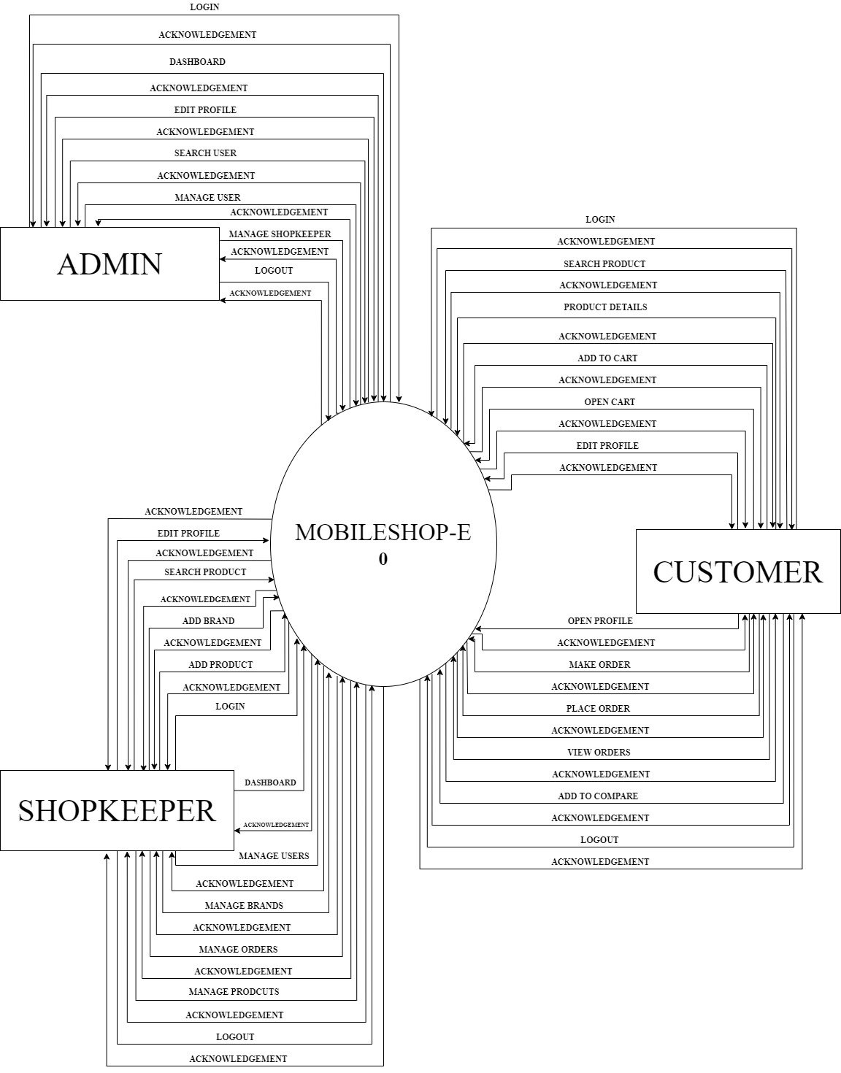

**[Figure 2: DFD level 0]**

2. Admin level 1:

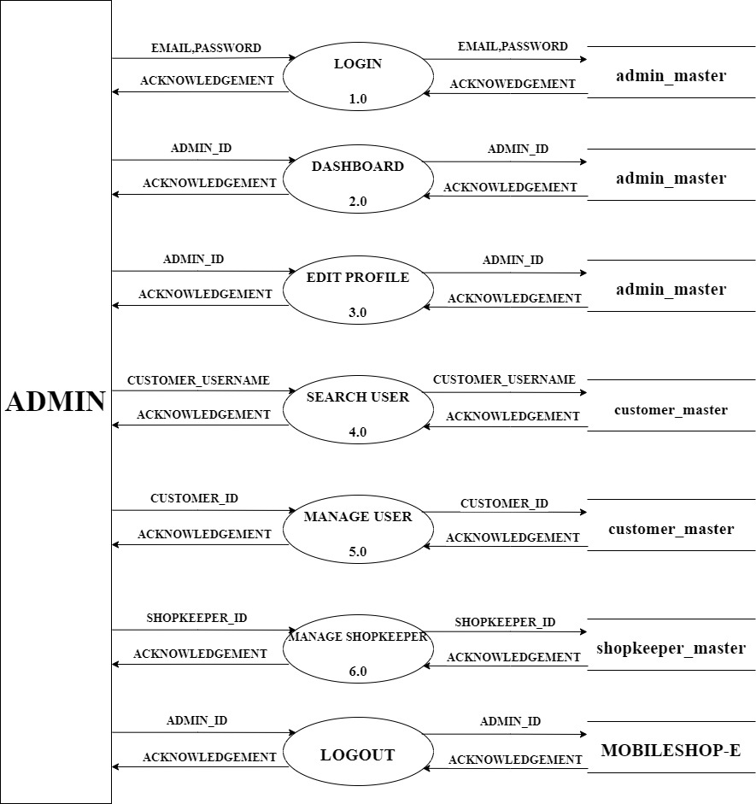

**[Figure 3: Admin level 1]**

3. Shopkeeper level 1:

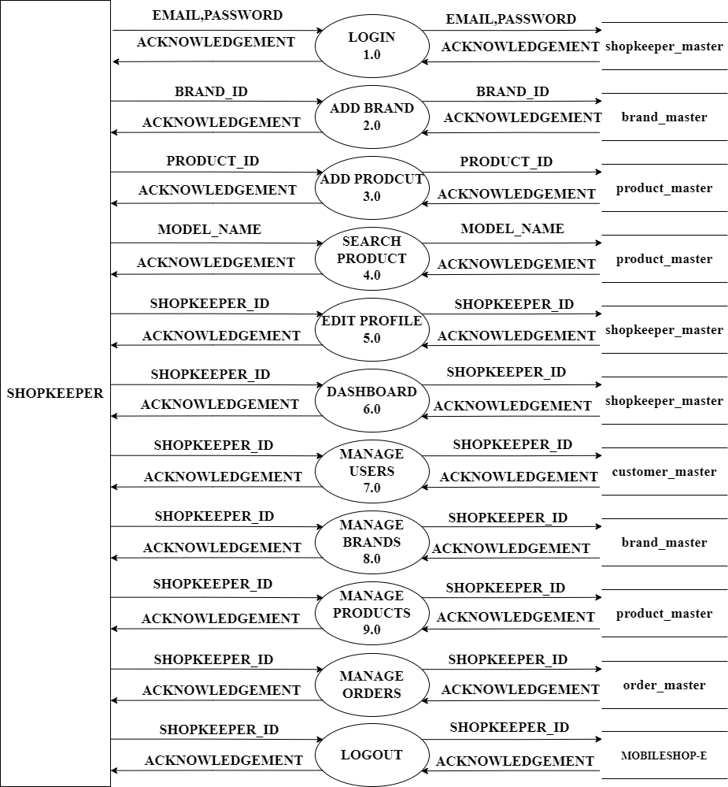

**[Figure 4: Shopkeeper level 1]**

3. Customer level 1:

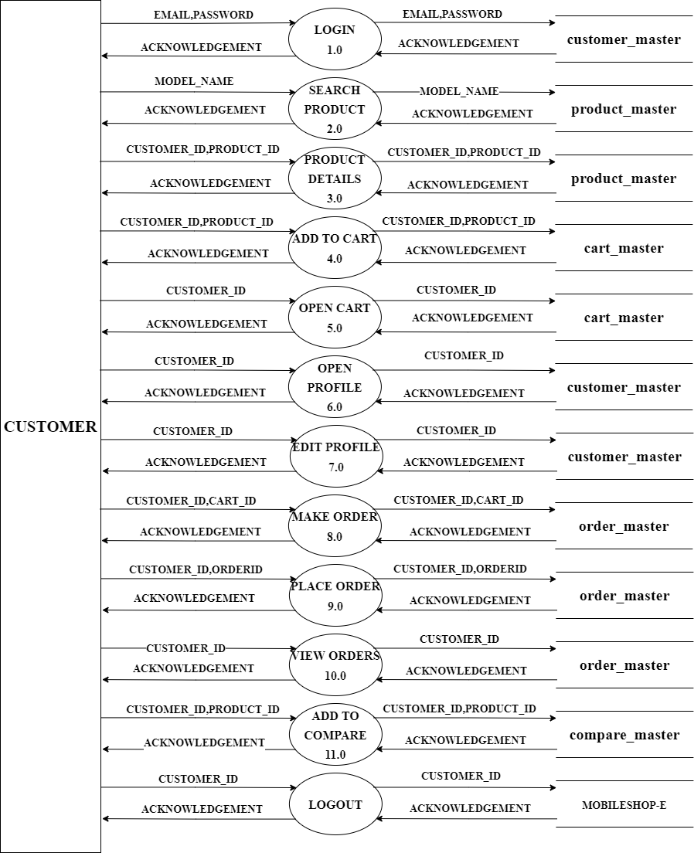  
**[Figure 4: Customer level 1]**

## 3.2 ER diagram

An Entity Relationship (ER) Diagram is a type of flowchart that illustrates how “entities” such as people, objects or concepts relate to each other within a system. ER Diagrams are most often used to design or debug relational databases in the fields of software engineering, business information systems, education and research. Also known as ERDs or ER Models, they use a defined set of symbols such as rectangles, diamonds, ovals and connecting lines to depict the interconnectedness of entities, relationships and their attributes. They mirror grammatical structure, with entities as nouns and relationships as verbs.

Peter Chen (a.k.a. Peter Pin-Shan Chen), currently a faculty member at Carnegie-Mellon University in Pittsburgh, is credited with developing ER modeling for database design in the 1970s. While serving as an assistant professor at MIT’s Sloan School of Management, he published a seminal paper in 1976 titled “The Entity-Relationship Model: Toward a Unified View of Data.”

* ER model allows you to draw Database Design
* It is an easy-to-use graphical tool for modeling data
* Widely used in Database Design
* It is a GUI representation of the logical structure of a Database
* It helps you to identify the entities which exist in a system and the relationships between those entities.

**[Table 3: ER-Diagram symbols]**

|  |  |
| --- | --- |
| **Symbols** | **Description** |
|  | **Entity:** Data object is real world entity or thing. |
|  | **Attributes:** An attribute is property of  Characteristic of an entity. |
| ---- | **Relationship:** Entity are connected each other via relations. Generally, relationships in binary because there are two entities are  Related to each other. |
|  | **Cardinality (One to One):** An instance of entity A can relate to one only instance of B And vice versa. |
|  | **Cardinality (One to Many):** An instance of entity A can relate to one or many instances of B but be can only relate one instance of A. |
|  | **Cardinality (Many to One):** Many instances of entity A can relate to one instances of entity B and vice versa |
|  | **Cardinality (Many to Many):** One or more instances of entity A can relate to one more instance of entity B and vice versa. |

ER-Diagram**:**

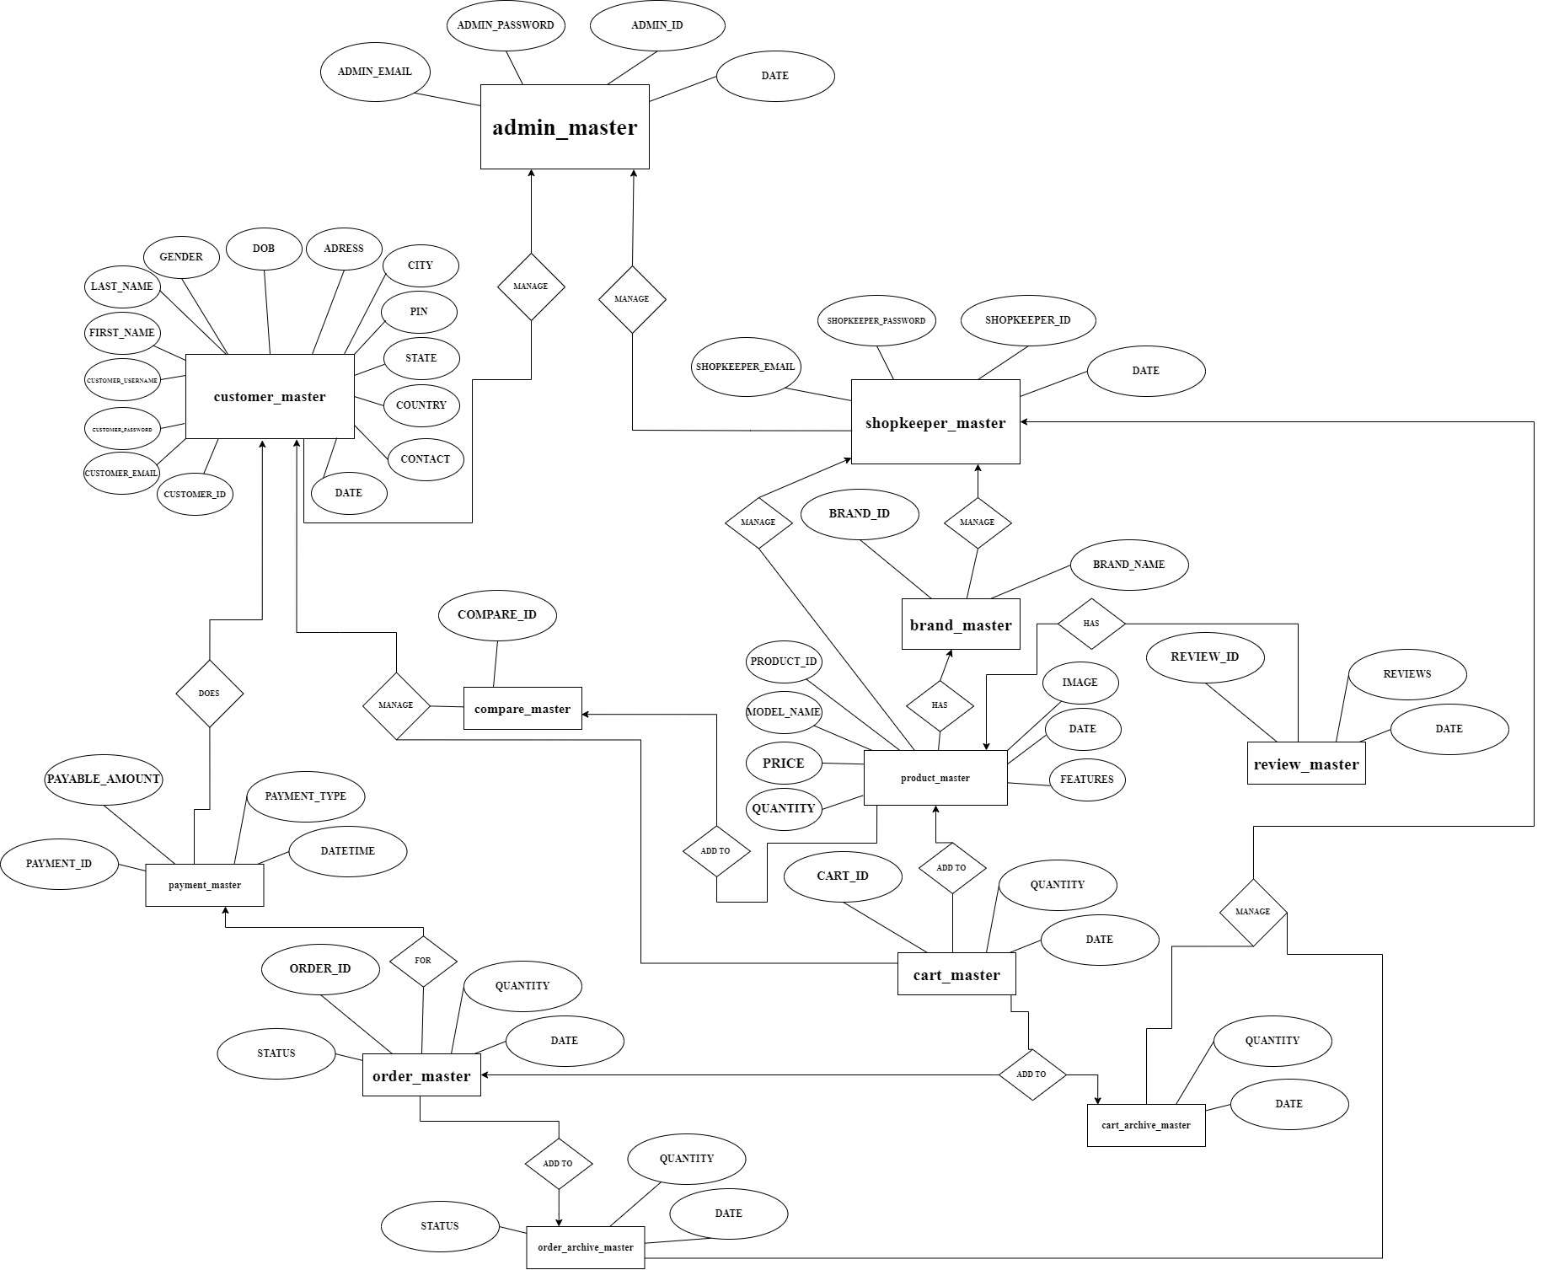

**[Figure 6: ER-Diagram]**

**CHAPTER-4**

**SYSTEM MODELING**

**4.1 Data dictionary**

A data dictionary is a collection of descriptions of the data objects or items in a data model for the benefit of programmers and others who need to refer to them. A first step in analyzing a system of objects with which users interact is to identify each object and its relationship to other objects. This process is called data modeling and results in a picture of object relationships. After each data object or item is given a descriptive name, its relationship is described (or it becomes part of some structure that implicitly describes relationship), the type of data (such as text or image or binary value) is described, possible predefined values are listed, and a brief textual description is provided. This collection can be organized for reference into a book called a data dictionary.

When developing programs that use the data model, a data dictionary can be consulted to understand where a data item fits in the structure, what values it may contain, and basically what the data item means in real-world terms. For example, a bank or group of banks could model the data objects involved in consumer banking. They could then provide a data dictionary for a bank's programmers. The data dictionary would describe each of the data items in its data model for consumer banking (for example, "Account holder" and "Available credit").

**4.2 Database designing**

**Data dictionary:**

Database name: OEMS

Table name: -admin_master

Primary key: -ADMIN_ID

Foreign key: -N/A

**[Table 4: admin_master]**

|  |  |  |  |
| --- | --- | --- | --- |
| Field name | Data type | Constraints | Description |
| ADMIN_ID | Int (10) | Primary key, auto increment | Admin id |
| ADMIN_EMAIL | Varchar (50) | Not null | Admin email |
| ADMIN_PASSWORD | Varchar (100) | Not null | Admin password |
| DATE | Timestamp (6) | Not null | Login date & time |

Table name: -shopkeeper_master

Primary key: -SHOPKEEPER _ID

Foreign key: - ADMIN_ID

**[Table 5: shopkeeper_master]**

|  |  |  |  |
| --- | --- | --- | --- |
| Field name | Data type | Constraints | Description |
| SHOPKEEPER_ID | Int (10) | Primary key, auto increment | Shopkeeper id |
| DATE | Timestamp(6) | Not null | Date & Time |
| SHOPKEEPER_EMAIL | Varchar (50) | Not null | Shopkeeper email |
| SHOPKEEPER_PASSWORD | Varchar (100) | Not null | Shopkeeper password |

Table Name:-customer_master

Primary key:-CUSTOMER_ID

Foreign key:-ADMIN_ID

**[Table 6: customer_master]**

|  |  |  |  |
| --- | --- | --- | --- |
| Field name | Data type | Constraints | Description |
| CUSTOMER_ID | Int (10) | Primary key, auto increment | Customer id |
| ADMIN_ID | Int (10) | Foreign key | Admin id |
| CUSTOMER_USERNAME | Varchar(50) | Not null | Customer username |
| CUSTOMER_EMAIL | Varchar (50) | Not null | Customer email |
| CUSTOMER_PASSWORD | Varchar (50) | Not null | Customer password |
| FIRST_NAME | Varchar (50) | Not null | First name |
| LAST_NAME | Varchar (50) | Not null | Last name |
| GENDER | Varchar (10) | Not null | Gender |
| DOB | Varchar (50) | Not null | Date of birth |
| ADDRESS | Longtext (100) | Not null | Store address |
| CITY | Varchar (10) | Not null | City |
| PIN | Int (6) | Not null | Pin code |
| STATE | Varchar (10) | Not null | State |
| COUNTRY | Varchar (10) | Not null | Country |
| CONTACT | Varchar (20) | Not null | Phone number |
| Date | Timestamp (6) | Not null | Signup date and time |

Table Name: -brand_master

Primary key: -BRAND_ID

Foreign key: -SHOPKEEPER_ID

**[Table 7: brand_master]**

|  |  |  |  |
| --- | --- | --- | --- |
| Field name | Data type | Constraints | Description |
| BRAND_ID | Int (10) | Primary key, auto increment | Brand id |
| SHOPKEEPER_ID | Int (10) | Foreign key | Shopkeeper id |
| BRAND_NAME | Varchar (50) | Not null | Brand name |

Table Name: -product_master

Primary key: -PRODUCT_ID

Foreign key: -BRAND_NAME, SHOPKEEPER_ID

**[Table 8: product_master]**

|  |  |  |  |
| --- | --- | --- | --- |
| Field name | Data type | Constraints | Description |
| SHOPKEEPER_ID | Int (10) | Foreign key | Shopkeeper id |
| PRODUCT_ID | Int (10) | Primary key, auto increment | Product id |
| BRAND_ID | Int (10) | Foreign key | Brand id |
| MODEL_NAME | Varchar (100) | Not null | Model name |
| FEATURES | Longtext (1000) | Not null | Fetures of the product |
| IMAGE | Varchar (20) | Not null | Product images |
| PRICE | Varchar (20) | Not null | Price of the product |
| DATE | TIMESTAMP (6) | NOT NULL | Register date & time |

Table Name: -review_master

Primary key: -REVIEW_ID

Foreign key: -PRODUCT_ID, CUSTOMER_ID

**[Table 9: review_master]**

|  |  |  |  |
| --- | --- | --- | --- |
| Field name | Data type | Constraints | Description |
| REVIEW_ID | Int (10) | Primary key, auto increment | Review id |
| PRODUCT_ID | Int (10) | Foreign key | Product id |
| CUSTOMER_ID | Int (10) | Foreign key | Customer id |
| REVIEWS | Varchar (500) | Not null | Review of product |
| DATE | Timestamp (6) | Not null | Date and time of reviews |

Table Name: -cart_master

Primary key: -CART_ID

Foreign key: -CUSTOMER_ID, PRODUCT_ID

**[Table 10: cart_master]**

|  |  |  |  |
| --- | --- | --- | --- |
| Field name | Data type | Constraints | Description |
| CART_ID | Int (10) | Primary key, auto increment | Customer id |
| CUSTOMER_ID | Varchar (50) | Foreign key | Customer email |
| PRODUCT_ID | Varchar (100) | Foreign key | Customer password |
| QUANTITY | Int (10) | Not null | Quantity in cart |
| DATE | Timestamp (6) | Not null | Date and time of cart entry |

Table Name:-cart_archive_master

Primary key:-CART_ID

Foreign key:-CUSTOMER_ID, PRODUCT_ID

**[Table 11: cart_archive_master]**

|  |  |  |  |
| --- | --- | --- | --- |
| Field name | Data type | Constraints | Description |
| CART_ID | Int(10) | Primary key, auto increment | Customer id |
| CUSTOMER_ID | Varchar(50) | Foreign key | Customer email |
| PRODUCT_ID | Varchar(100) | Foreign key | Customer password |
| QUANTITY | Int(10) | Not null | Quantity in cart |
| DATE | Timestamp(6) | Not null | Date and time of deleted cart |

Table Name:-order_master

Primary key:-ORDER_ID

Foreign key:-CART_ID,CUSTOMER_ID,SHOPKEEPER_ID

**[Table 12: order_master]**

|  |  |  |  |
| --- | --- | --- | --- |
| Field name | Data type | Constraints | Description |
| ORDER_ID | Int(10) | Primary key, auto increment | Order id |
| CART_ID | Int(10) | Foreign key | Cart id |
| CUSTOMER_ID | Int(10) | Foreign key | Customer id |
| SHOPKEEPER_ID | Int(10) | Foreign key | Shopkeeper id |
| TOTAL | Varchar(20) | Not null | Total amount including taxes |
| STATUS | Varchar(20) | Not null | Current state of the order |
| QUANTITY | Int(10) | Not null | Product quantity in the product |
| DATE | Timestamp(6) | Not null | Date & time of order entry |

Table Name:-order_archive_master

Primary key:-ORDER_ID

Foreign key:-CART_ID,CUSTOMER_ID,SHOPKEEPER_ID

**[Table 13: order_archive_master]**

|  |  |  |  |
| --- | --- | --- | --- |
| Field name | Data type | Constraints | Description |
| ORDER_ID | Int(10) | Primary key, auto increment | Order id |
| CART_ID | Int(10) | Foreign key | Cart id |
| CUSTOMER_ID | Int(10) | Foreign key | Customer id |
| SHOPKEEPER_ID | Int(10) | Foreign key | Shopkeeper id |
| TOTAL | Varchar(20) | Not null | Total amount including taxes |
| QUANTITY | Int(10) | Not null | Product quantity in the product |
| DATE | Timestamp(6) | Not null | Date & time of order entry |

Table Name:-payment_master

Primary key:-PAYMENT_ID

Foreign key:-ORDER_ID,CUSTOMER_ID

**[Table 14: payment_master]**

|  |  |  |  |
| --- | --- | --- | --- |
| Field name | Data type | Constraints | Description |
| PAYMENT_ID | Int(10) | Primary key, auto increment | Payment id |
| ORDER_ID | Int(10) | Foreign key | Order id |
| PAYMENT_TYPE | Varchar(20) | Not null | Payment type |
| PAYABLE_AMOUNT | Varchar(10) | Not null | Payable amount |
| DATETIME | datetime | Not null | Date and time |

**CHAPTER 5**

**TECHNICAL SPECIFICATION**

# **5.1 Hardware Specification**

**5.1.1 RAM:** 1GB

**5.1.2 Hardware storage needed:** 500MB

**5.1.3 Other hardware requirements:** N\A

# **5.2** **Platform**

**5.2.1 Supported Operating System:** Windows XP and

Above, MAC OS, Linux.

**5.2.2 Programming Server:** APACHE Server 2.4.46

**5.2.3 Framework:** N\A.

**5.3 Programming Language Used**

**5.3.1 Markup language:** HTML 5

**5.3.2 Programming Language:** PHP 8.0.9, JavaScript ES2015

**5.3.3 Style Sheet Language:** CSS 4

# **5.4 Technical Specification**

**5.4.1 Front-End:** HTML 5, CSS 4

**5.4.2 Back-End:** MySQL 5.7.23, PHP 8.0.9

**5.4.3 IDE:** Visual studio code

**5.4.4 UML Tools:** Draw.io 13.9.9

**5.4.5 SRS Tools:** Microsoft Word 2016

**5.5 Design layout**

**5.5.1 Home page**

**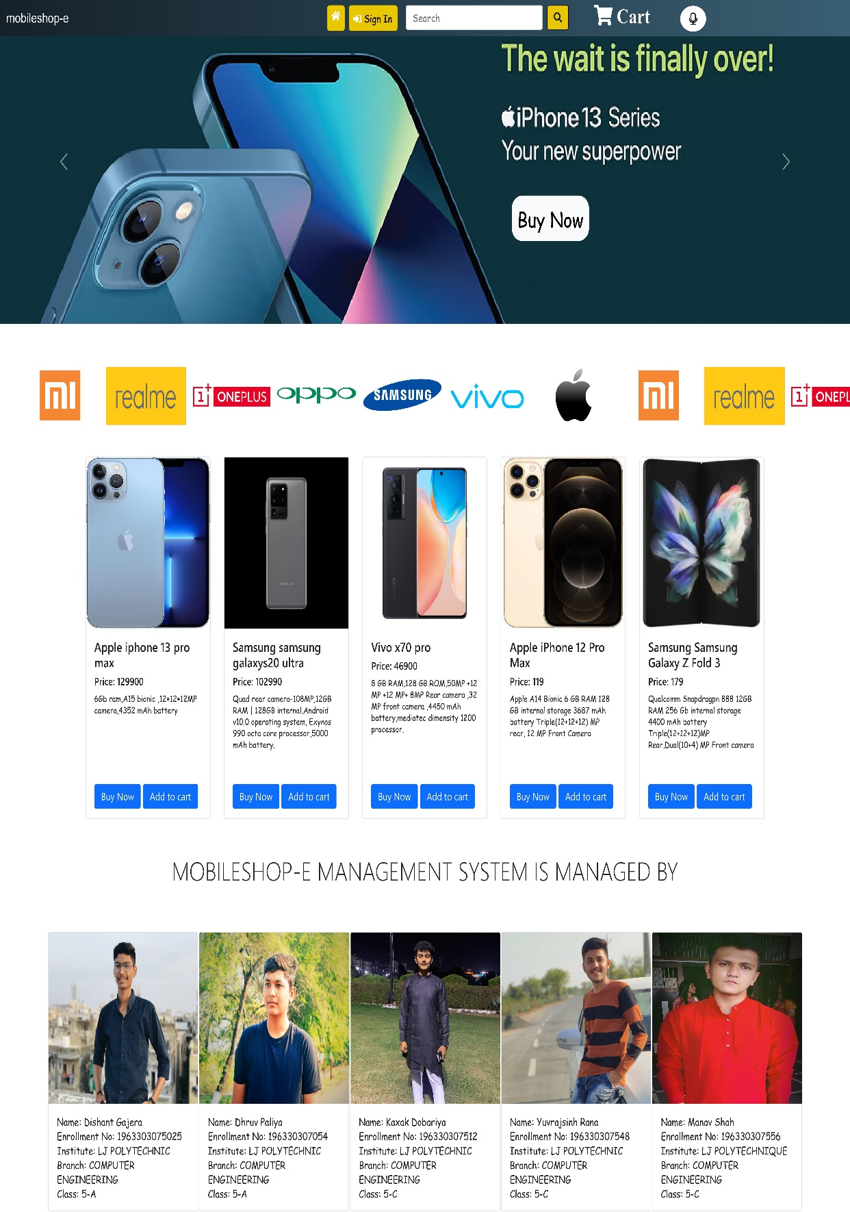  
[Figure: Home page]**

**5.5.2 Customer login page**

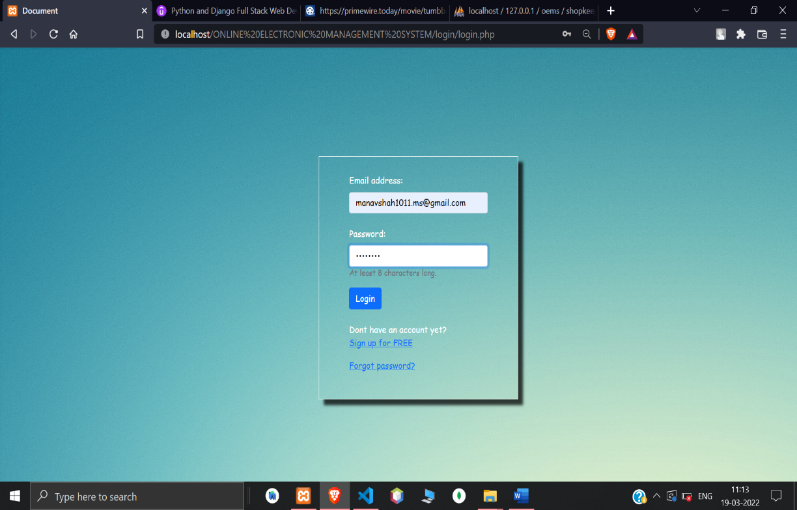

**[Figure: Customer login page]**

**5.5.2 Login page validations**

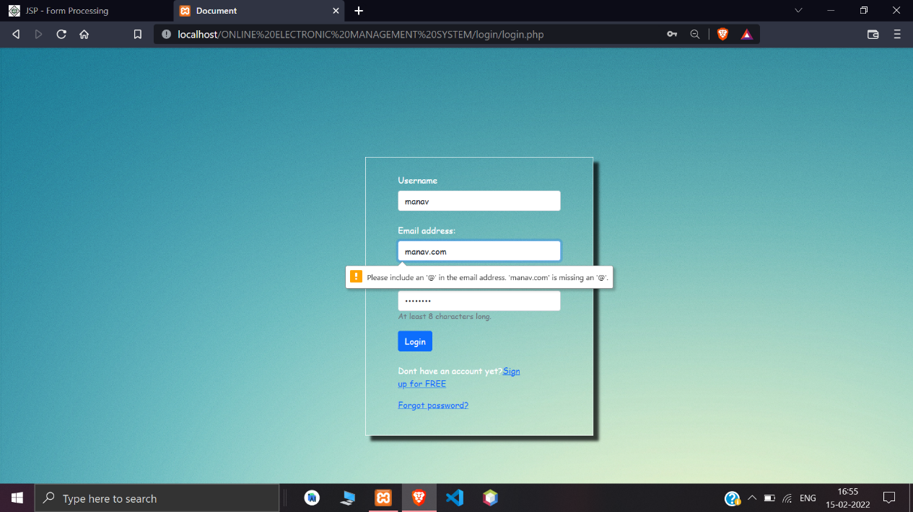

**[Figure: Login validations]**

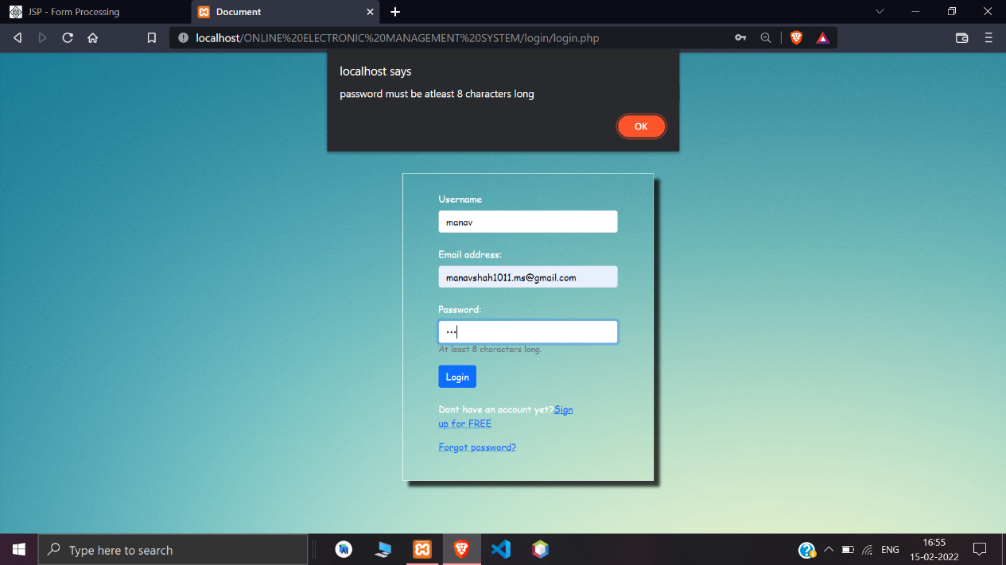

**[Figure: Login validations]**

**5.5.4 Sign-up page**

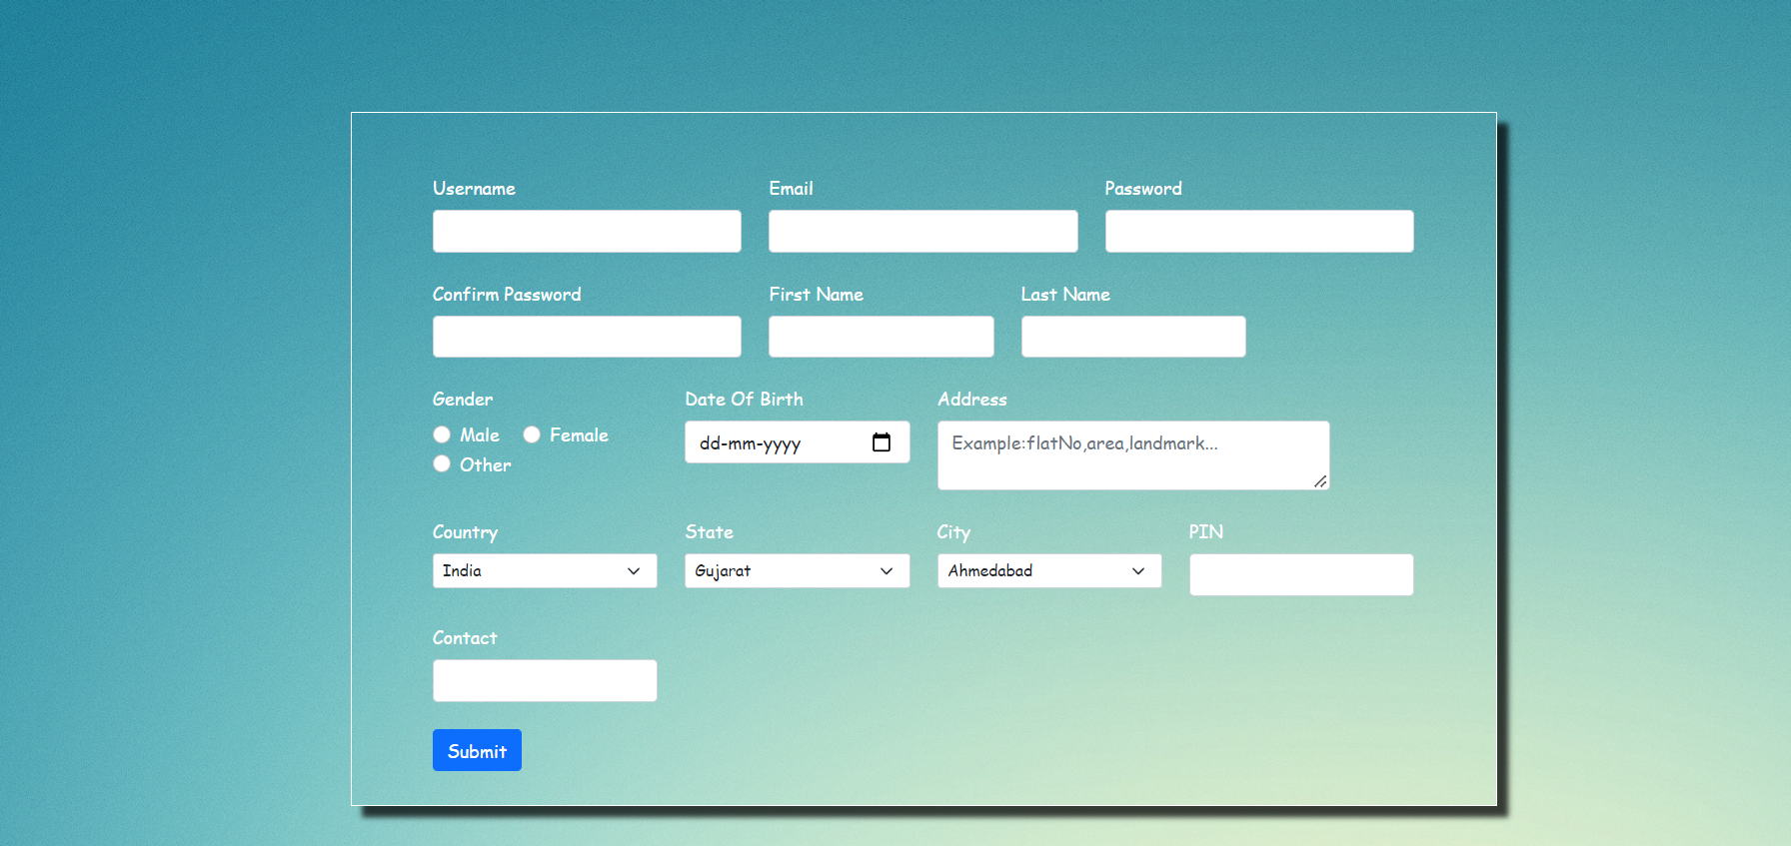

**[Figure: Signup page]**

**5.5.5 Sign-up page validations**

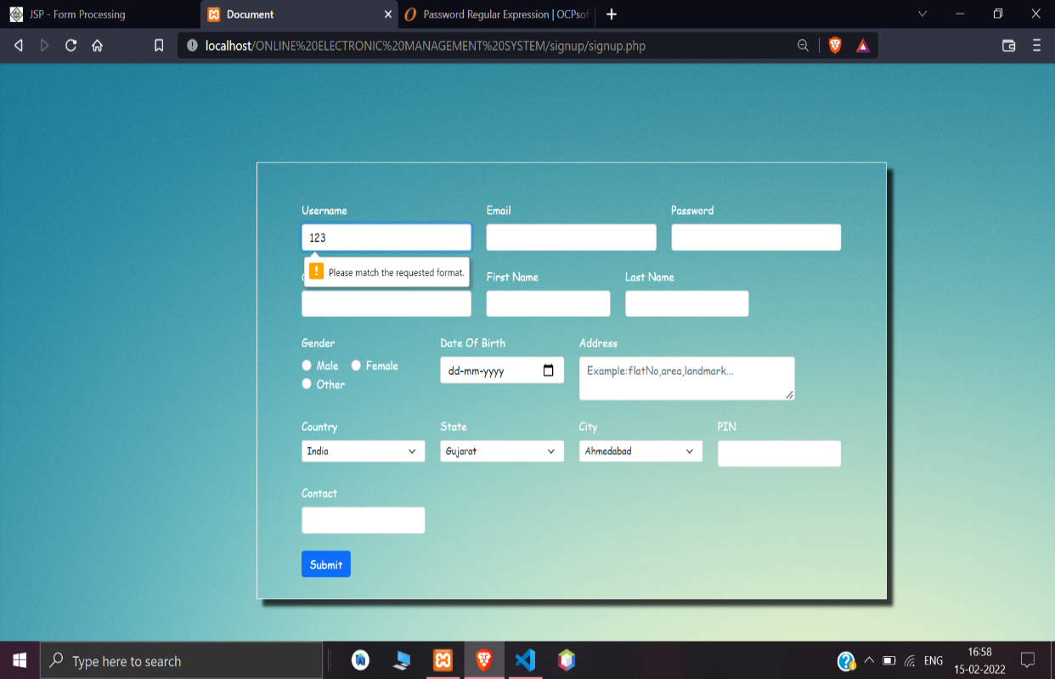

**[Figure: Signup page validations]**

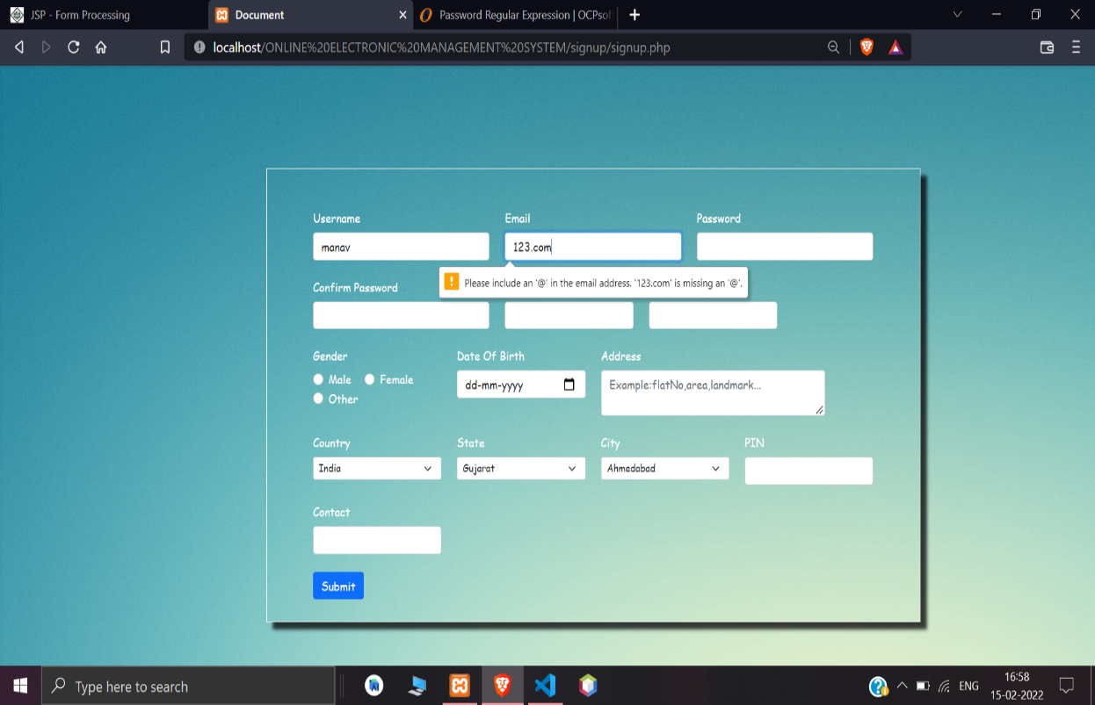

**[Figure: Signup page validations]**

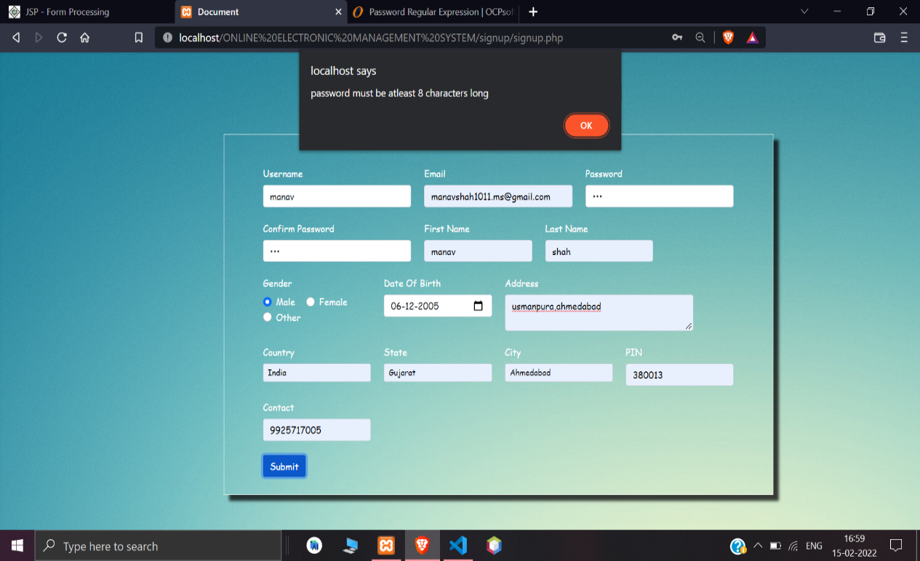

**[Figure: Signup page validations]**

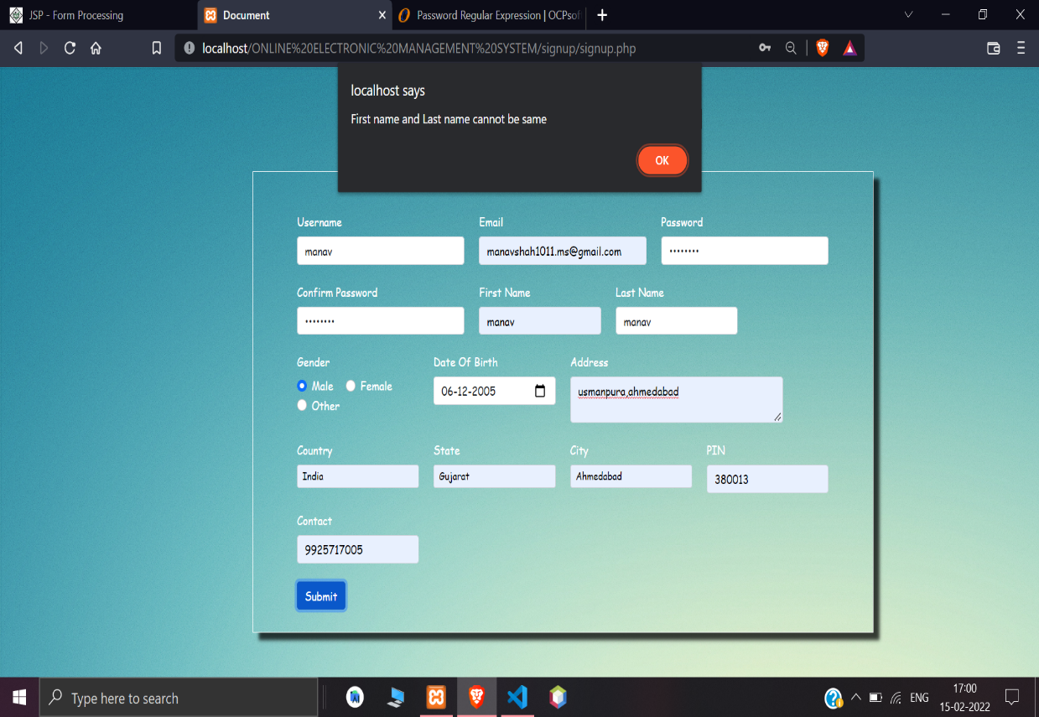

**[Figure: Signup page validations]**

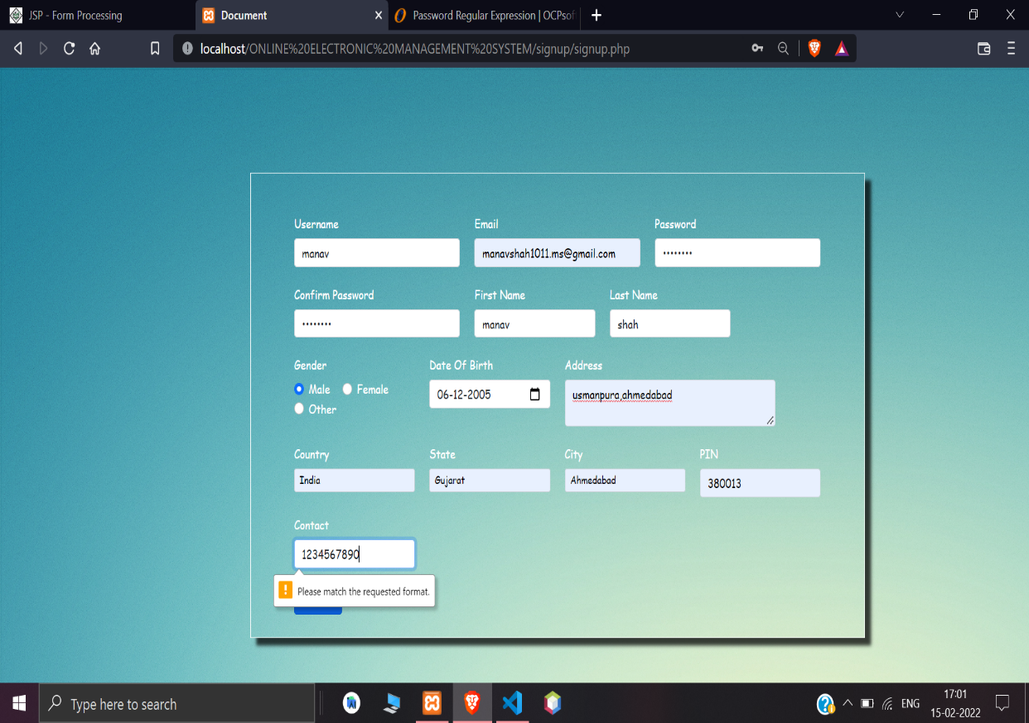

**[Figure: Signup page validations]**

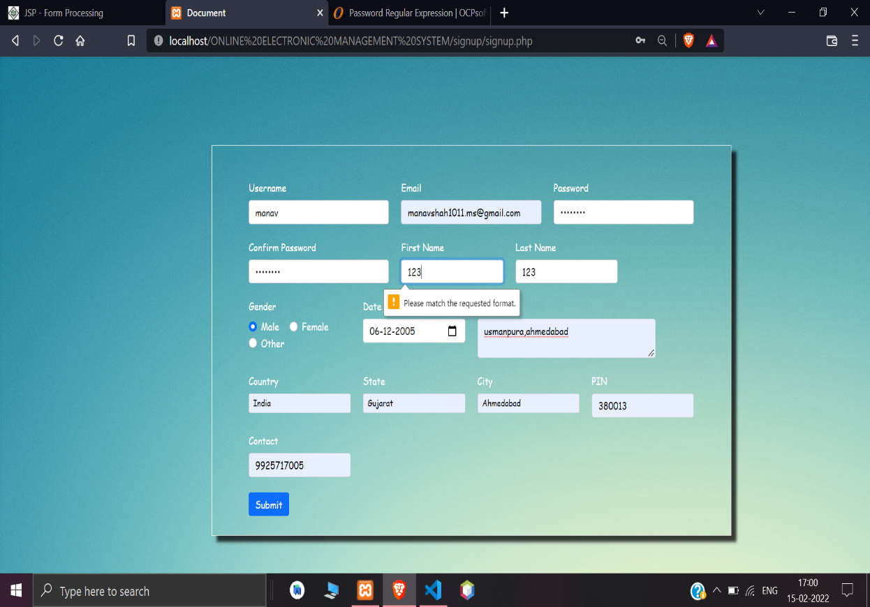

**[Figure: Signup page validations]**

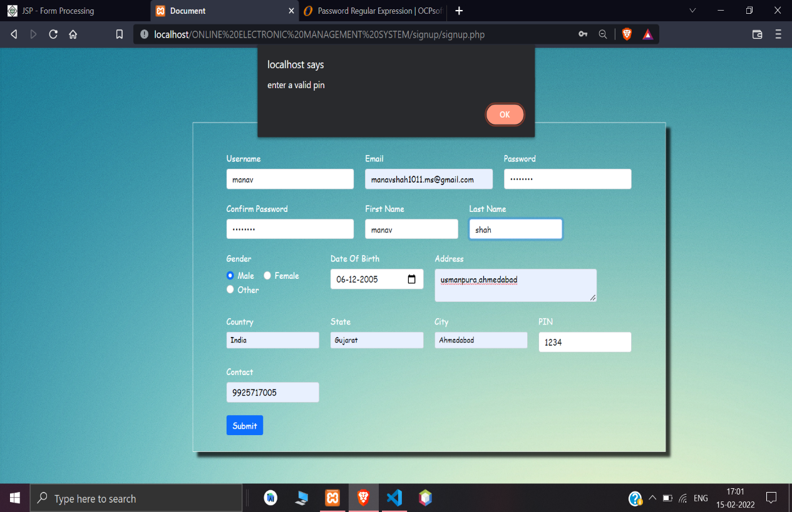

**[Figure: Signup page validations]**

**5.5.6 Enter otp for signup**

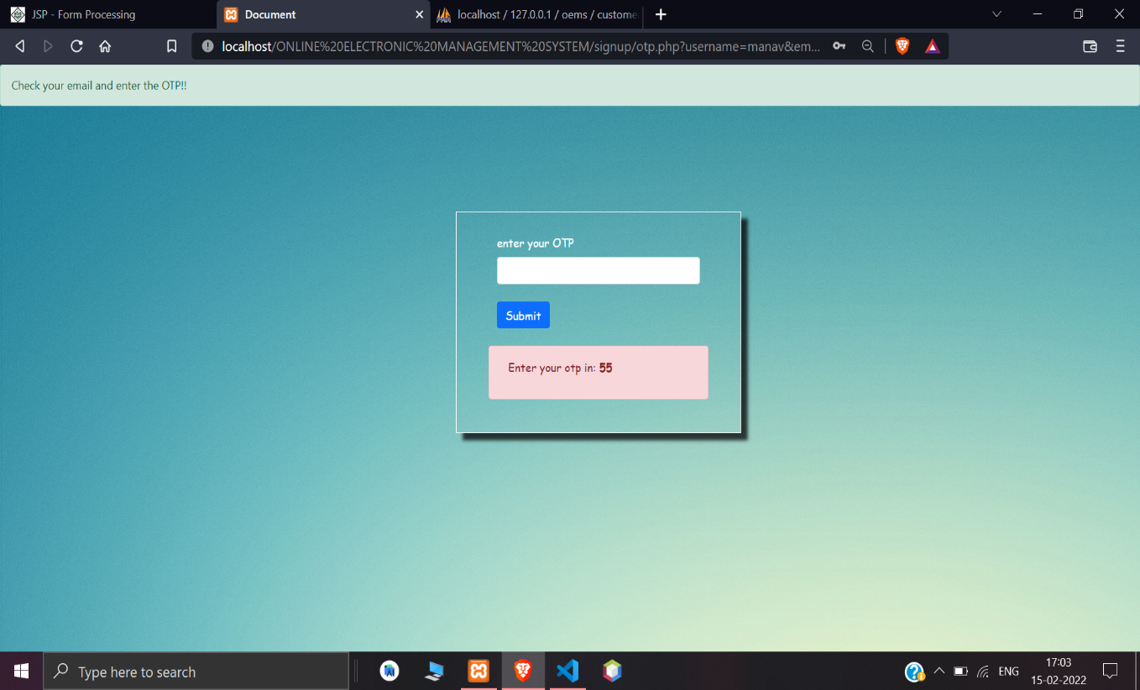**[Figure: Enter otp for signup page]**

**5.5.7 Otp validations**

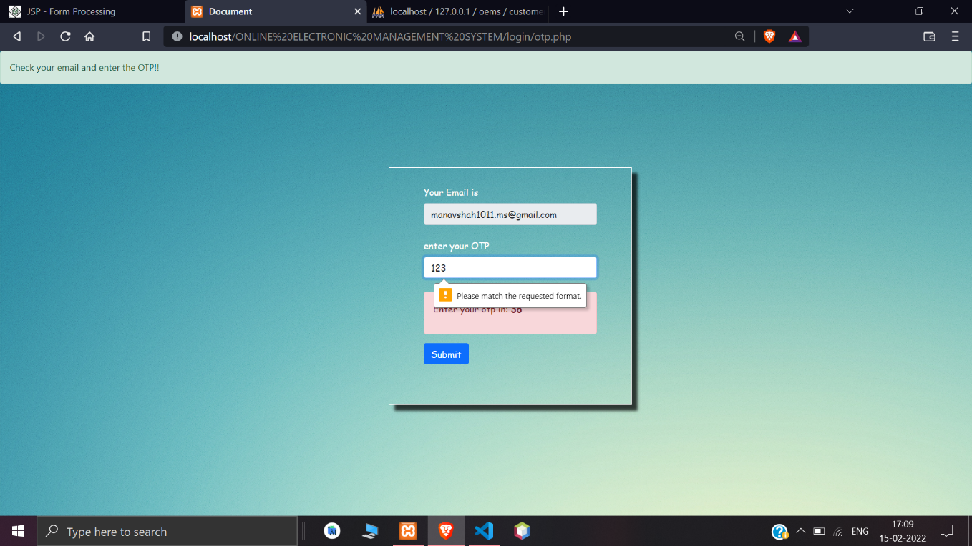

**[Figure: Otp validations]**

**5.5.8 Forgot password page**

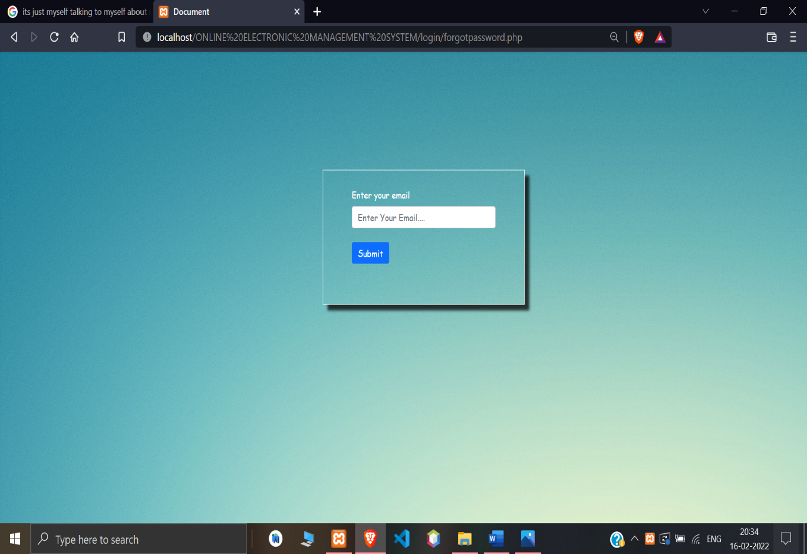

**[Figure: Forgot password page]**

**5.5.9 Forgot password page validations**

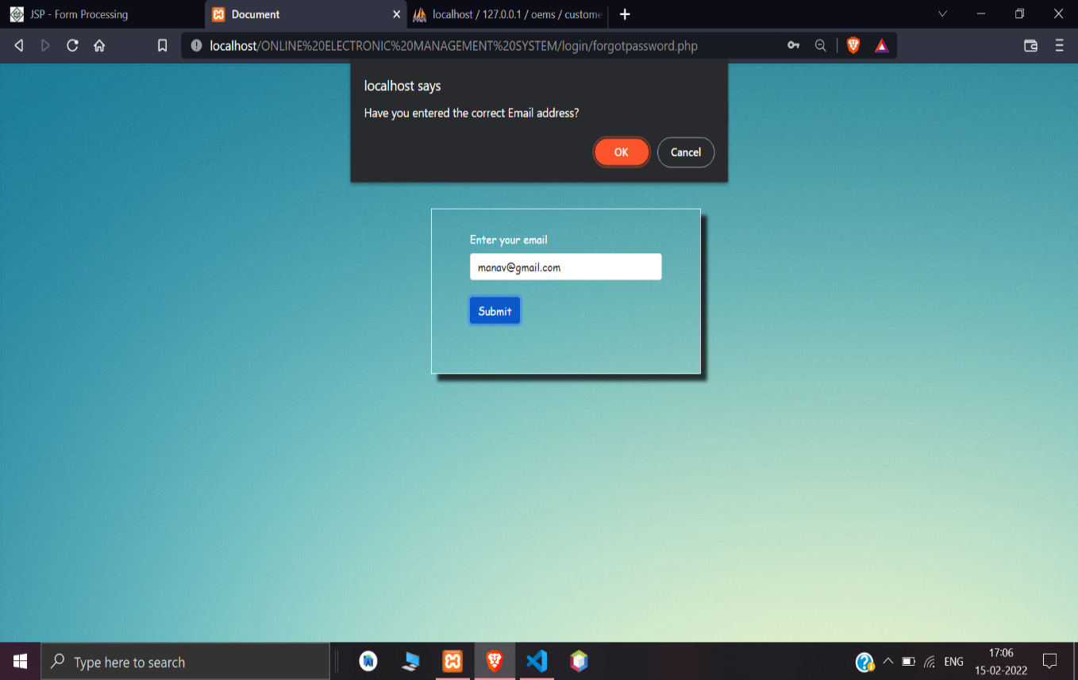

**[Figure: Forgot password validations]**

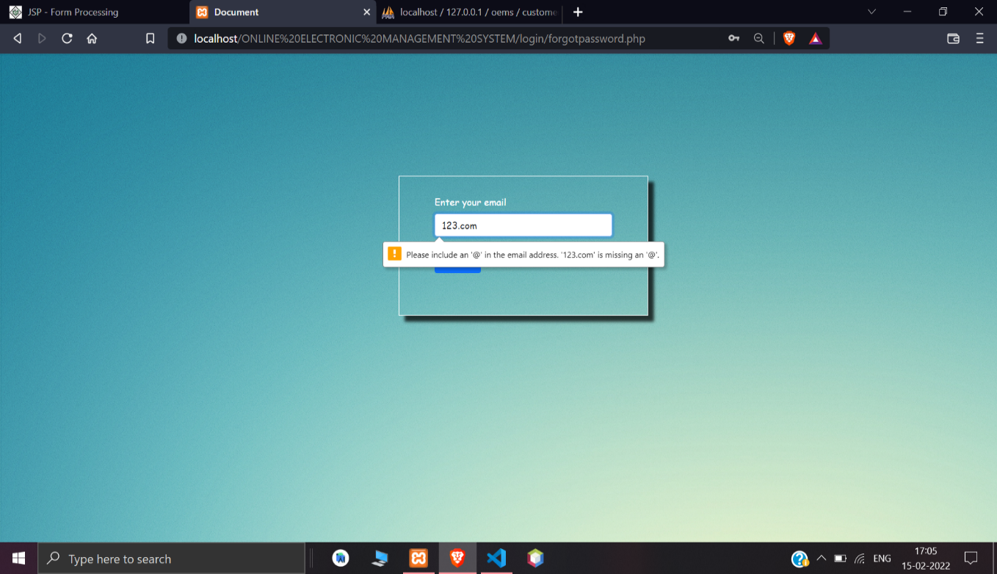

**[Figure: Forgot password validations]**

**5.5.10 Enter otp for forgot password**

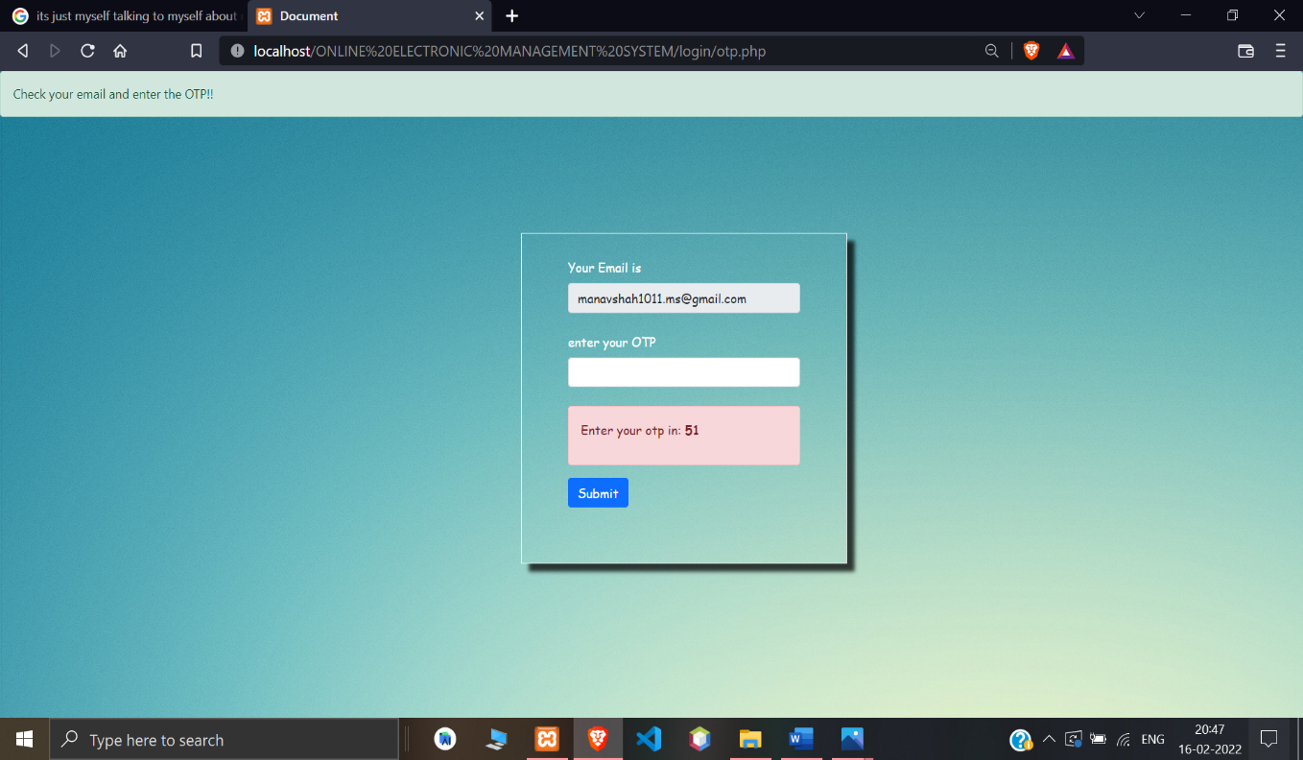

**[Figure: Enter otp for forgot password]**

**5.5.11 Otp validation**



**[Figure: Otp validations]**

**5.5.12 Invalid otp**

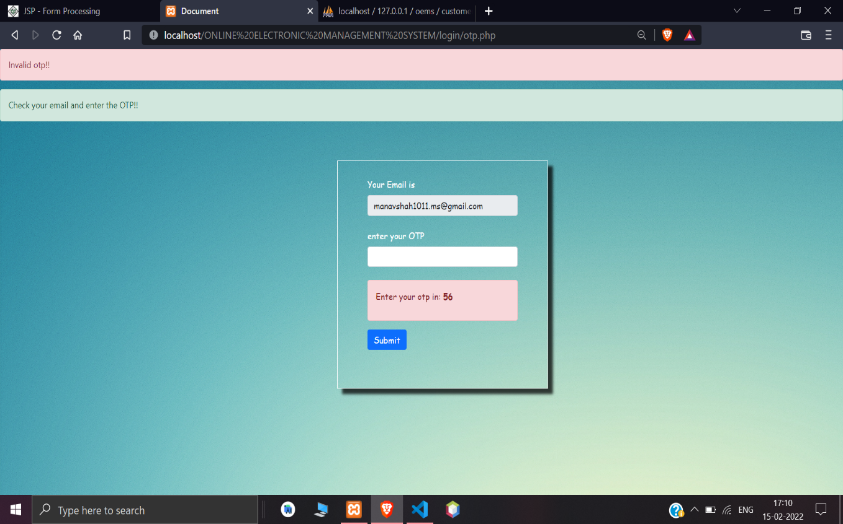

**[Figure: Invalid otp]**

**5.5.13 Reset password**

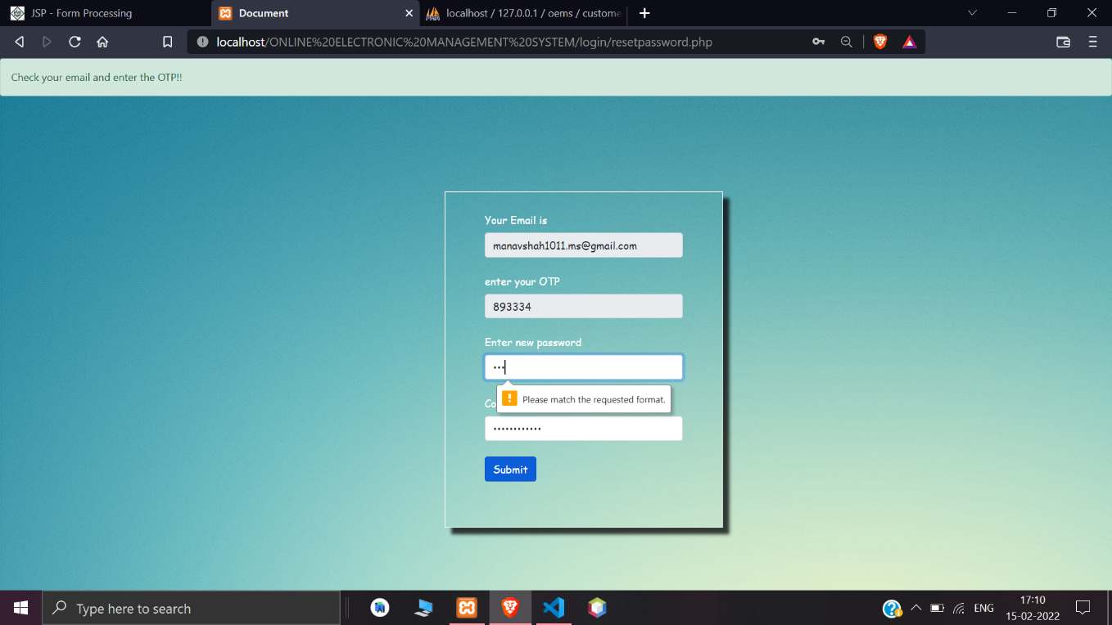

**[Figure: Reset password]**

**5.5.14 Password do not match**

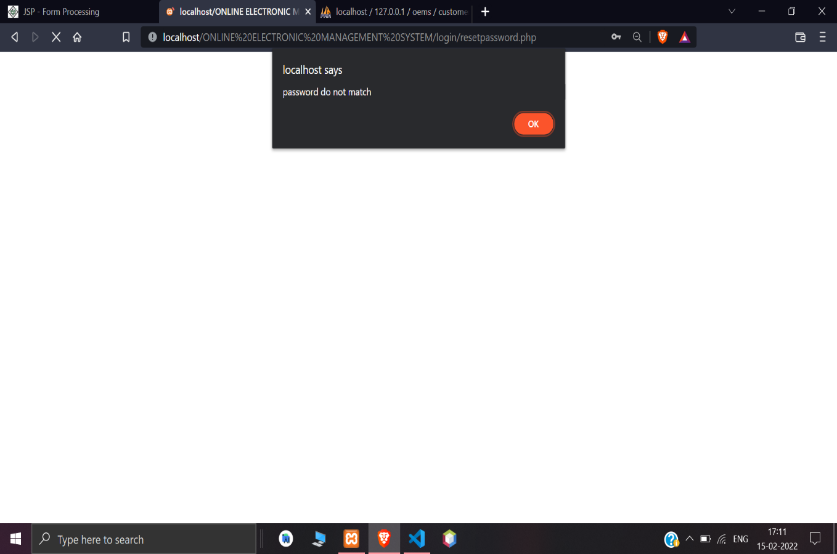

**[Figure: Password do not match]**

**5.5.15 Password reset successfully**

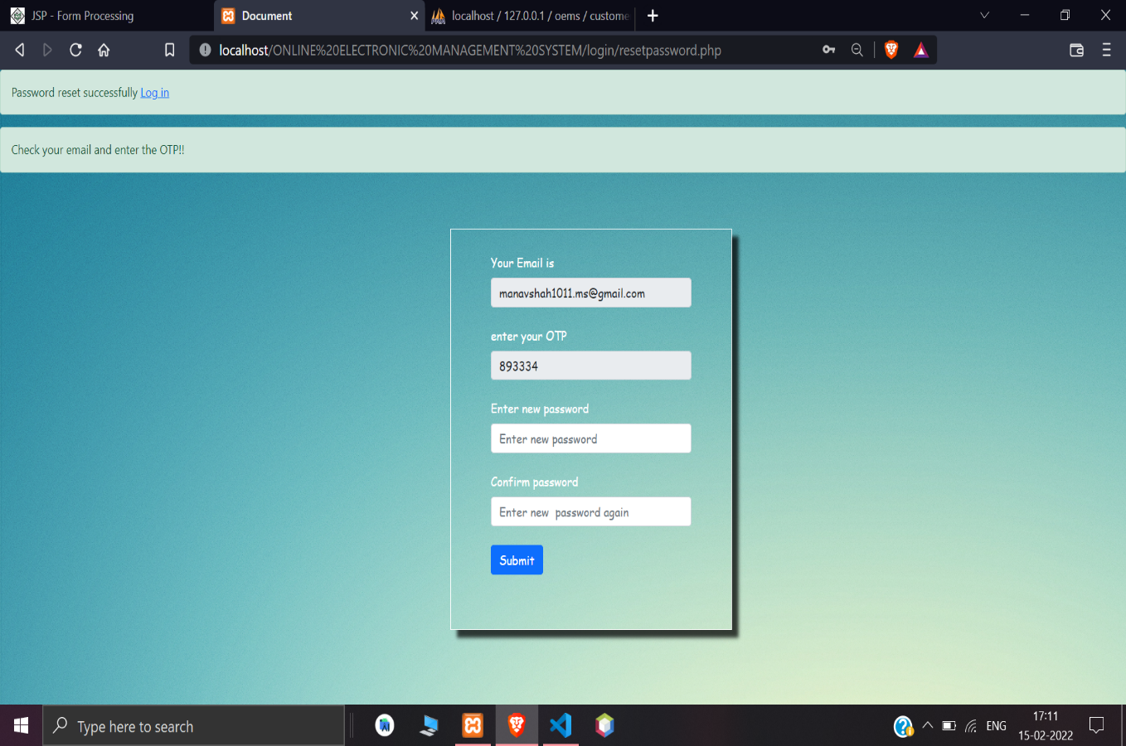

**[Figure: Password reset successfully]**

**5.5.16 Welcome page**

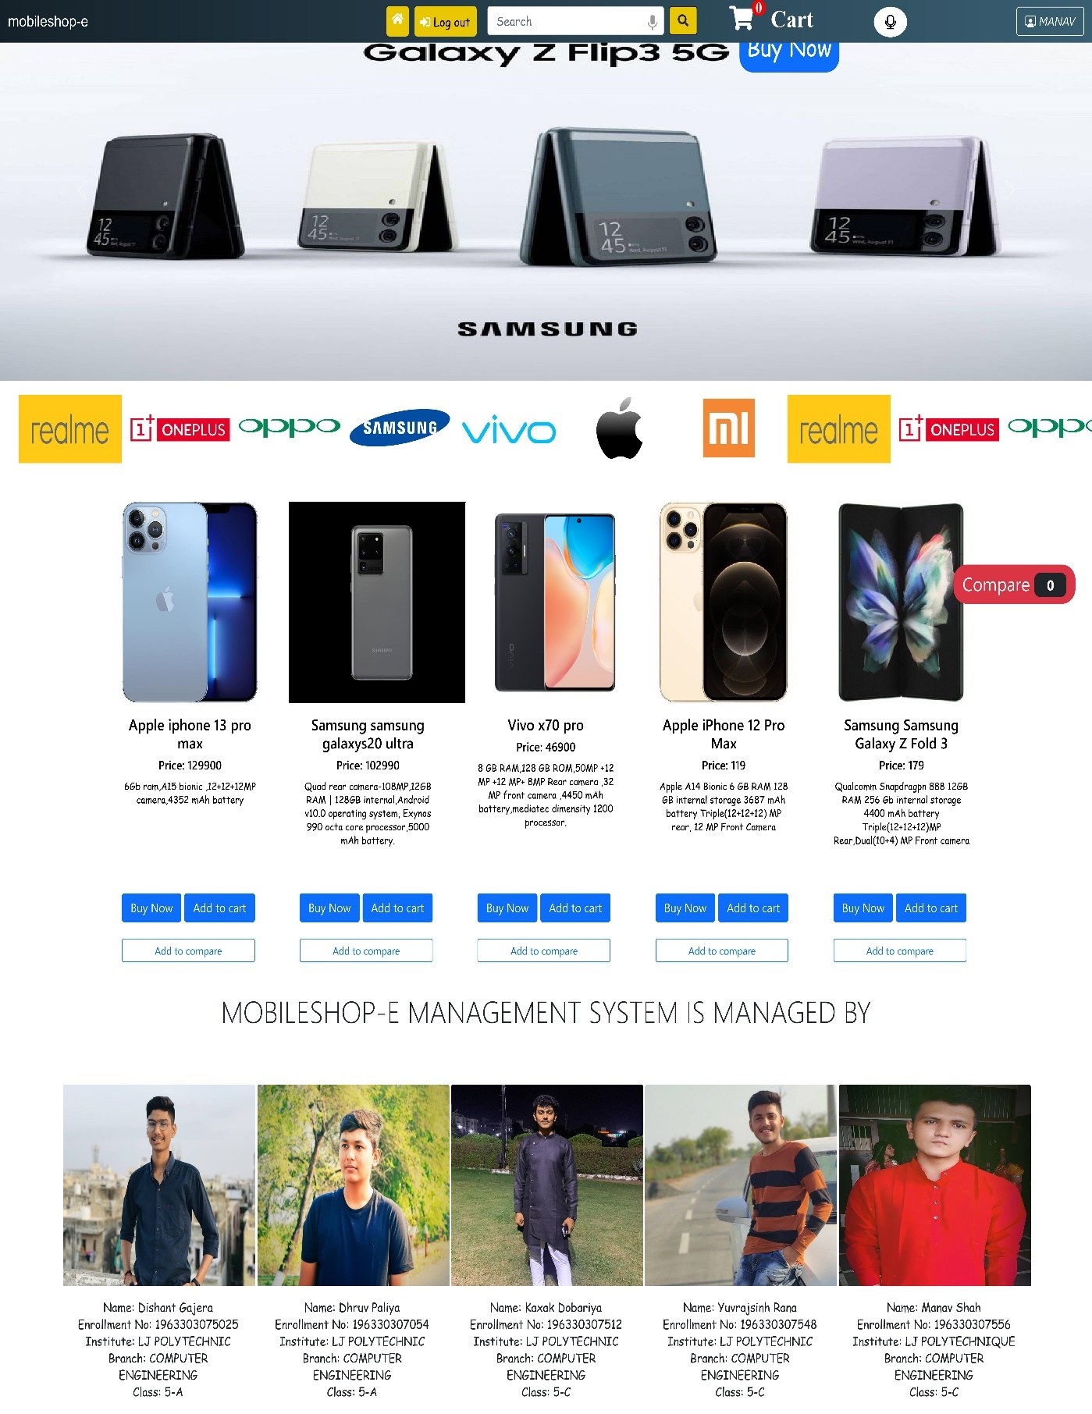

**[Figure: Welcome page]**

**5.5.17 View profile**

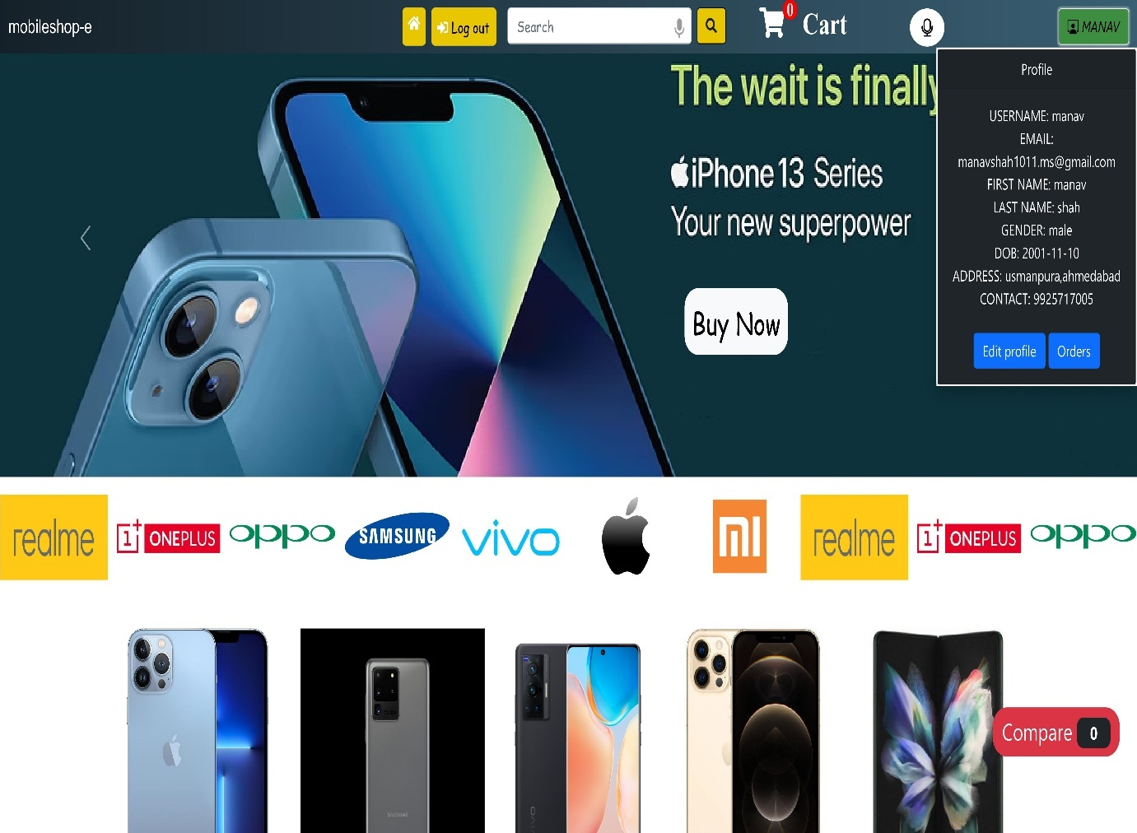

**[Figure: View profile]**

**5.5.18 Edit profile**

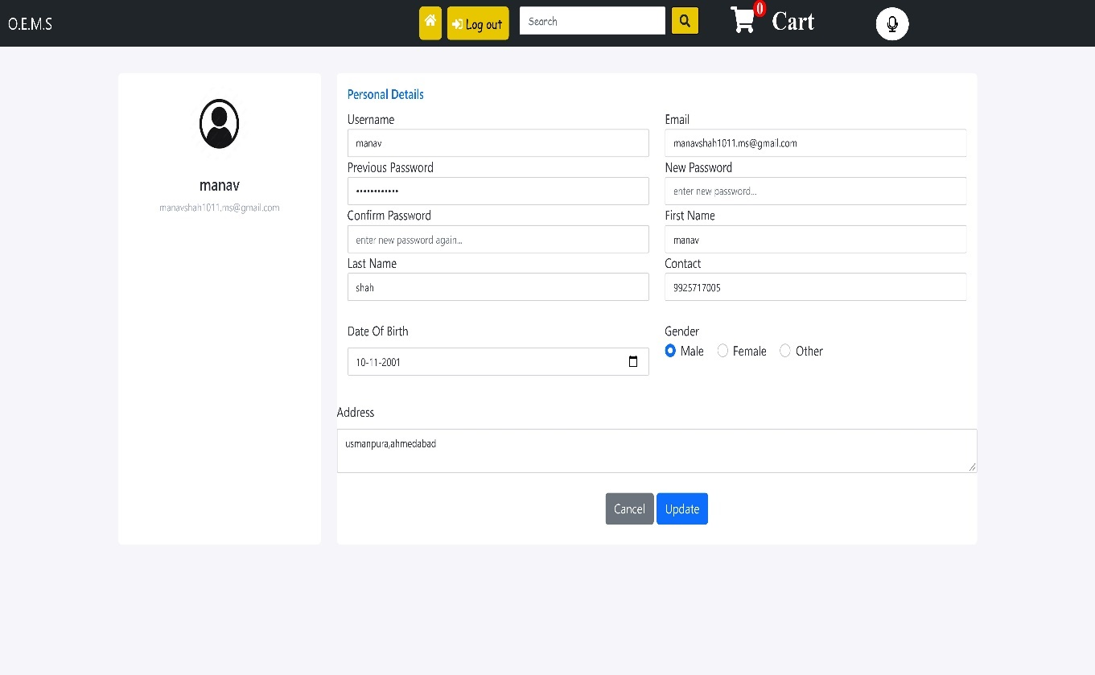

**[Figure: Edit profile]**

**5.5.19 Search product**

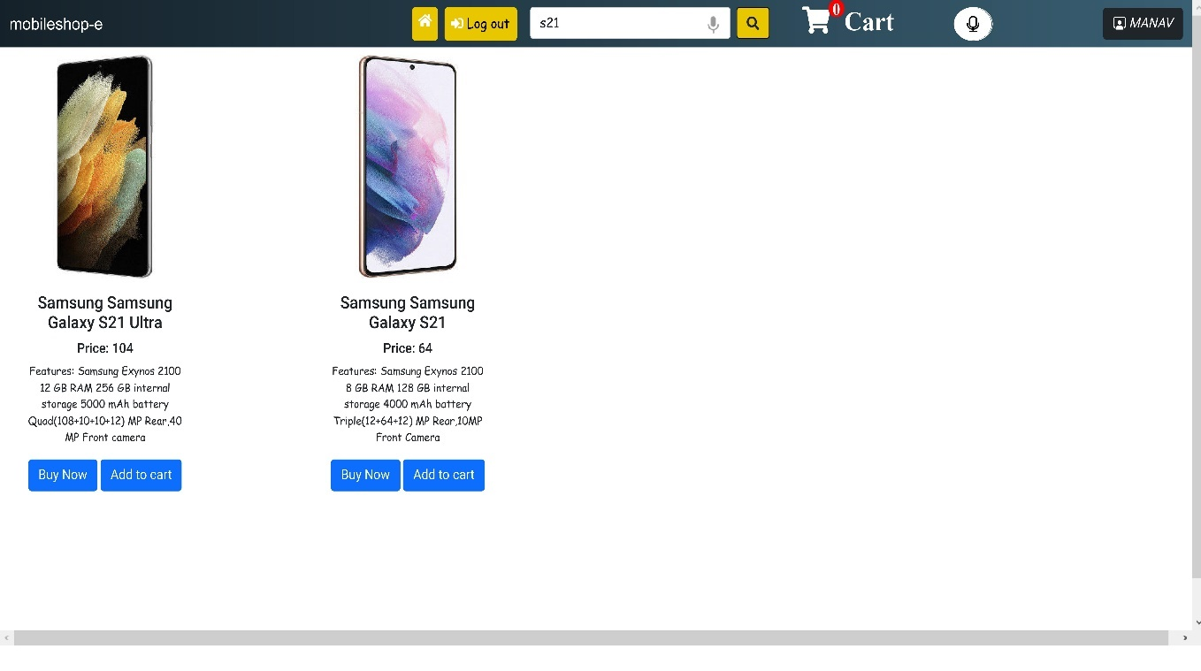

**[Figure: Search product]**

**5.5.20 Product detail**

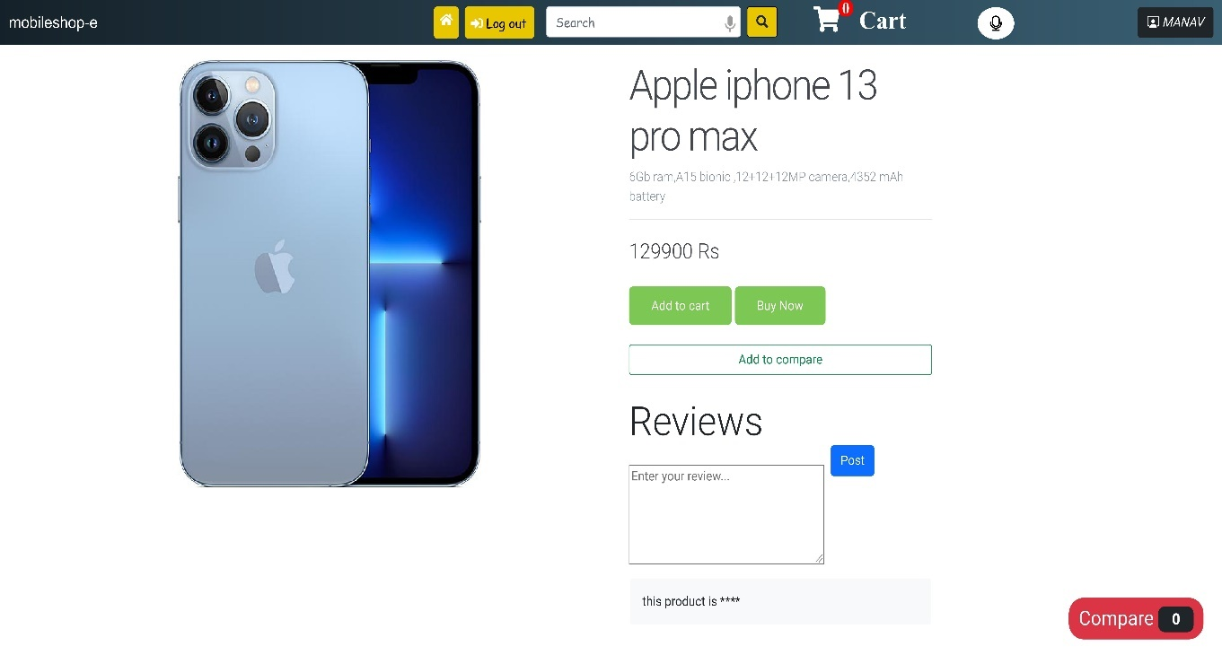

**[Figure: Product detail]**

**5.5.21 Add review**

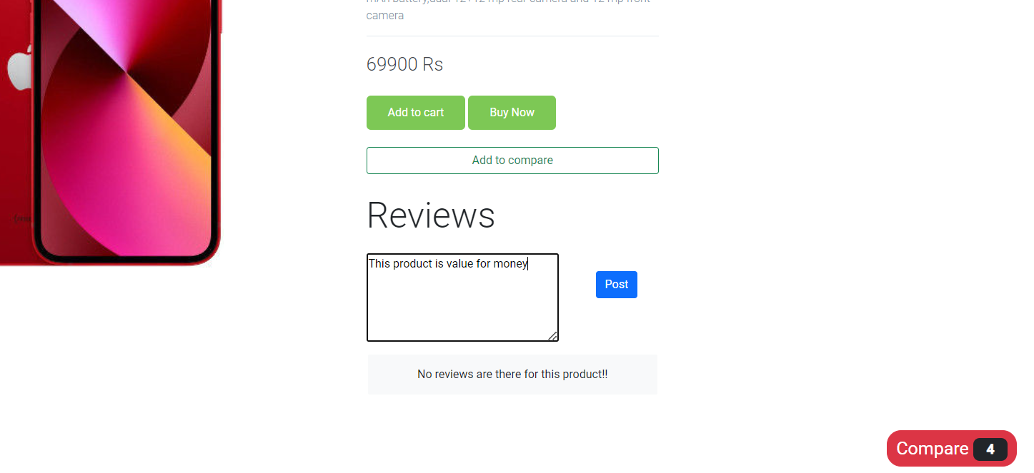

**[Figure: Add review]**

**5.5.22 Review added successfully**

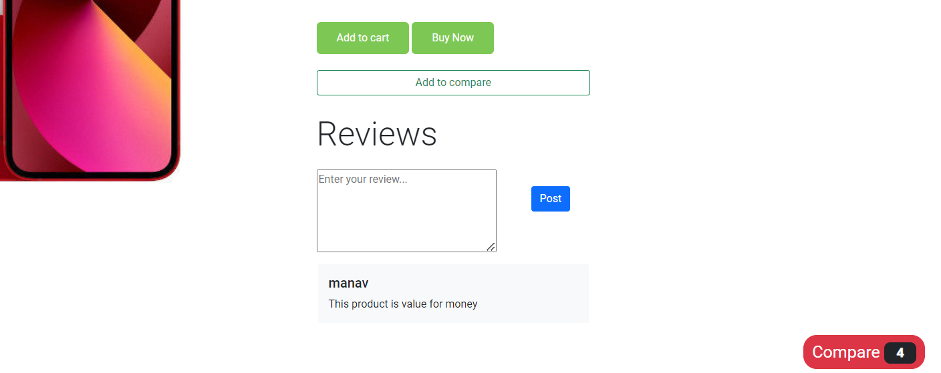

**[Figure: Review added successfully]**

**5.5.23 Review validation for abusive words**

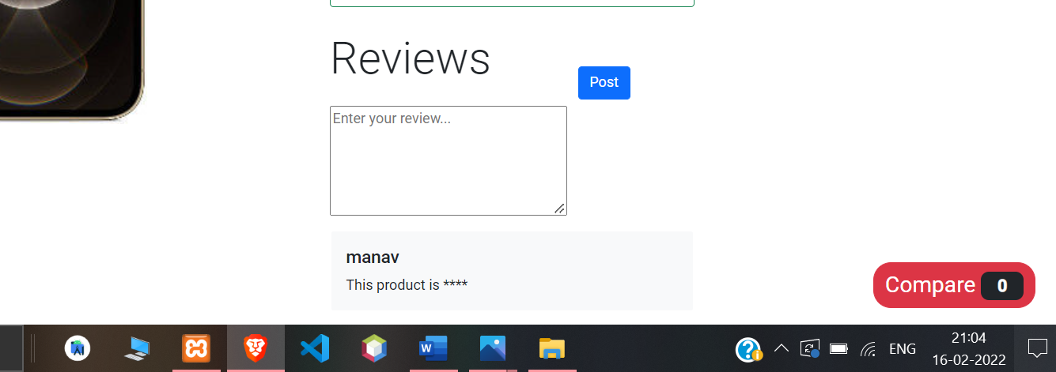

**[Figure: Abusive review validations]**

**5.5.24 Products in different brands**

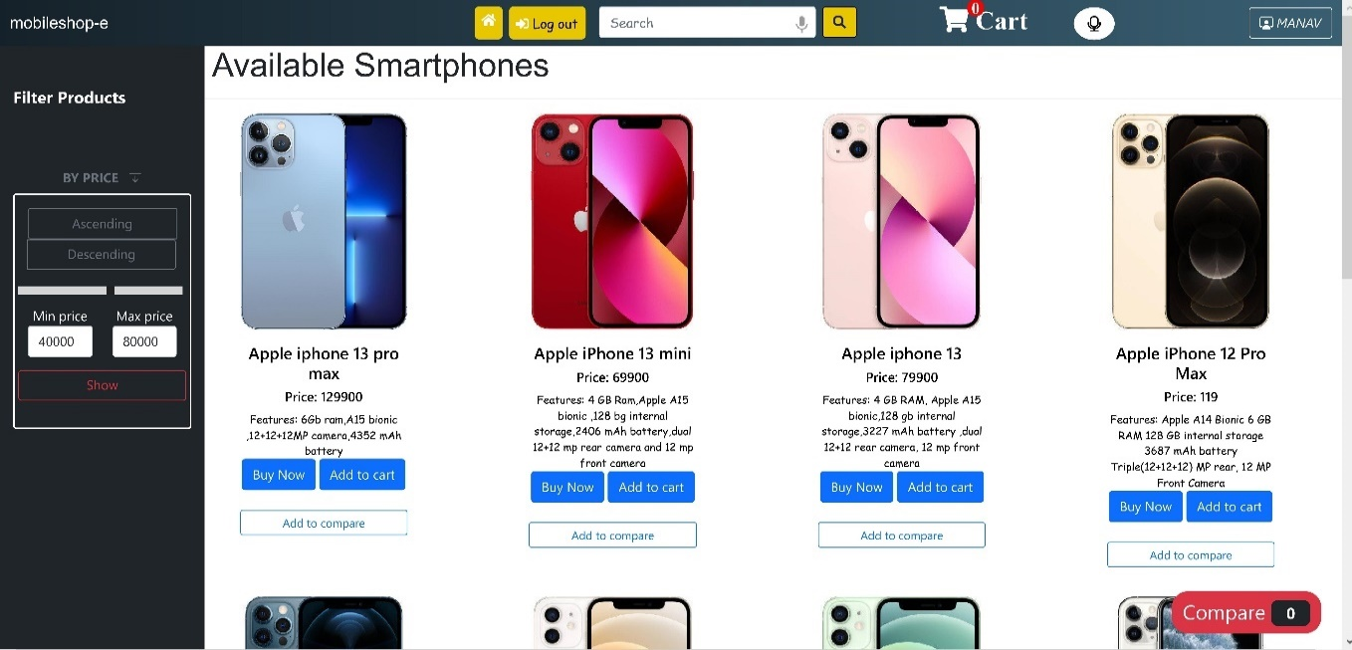

**[Figure: Product by brand]**

**5.5.25 Filter products by price**

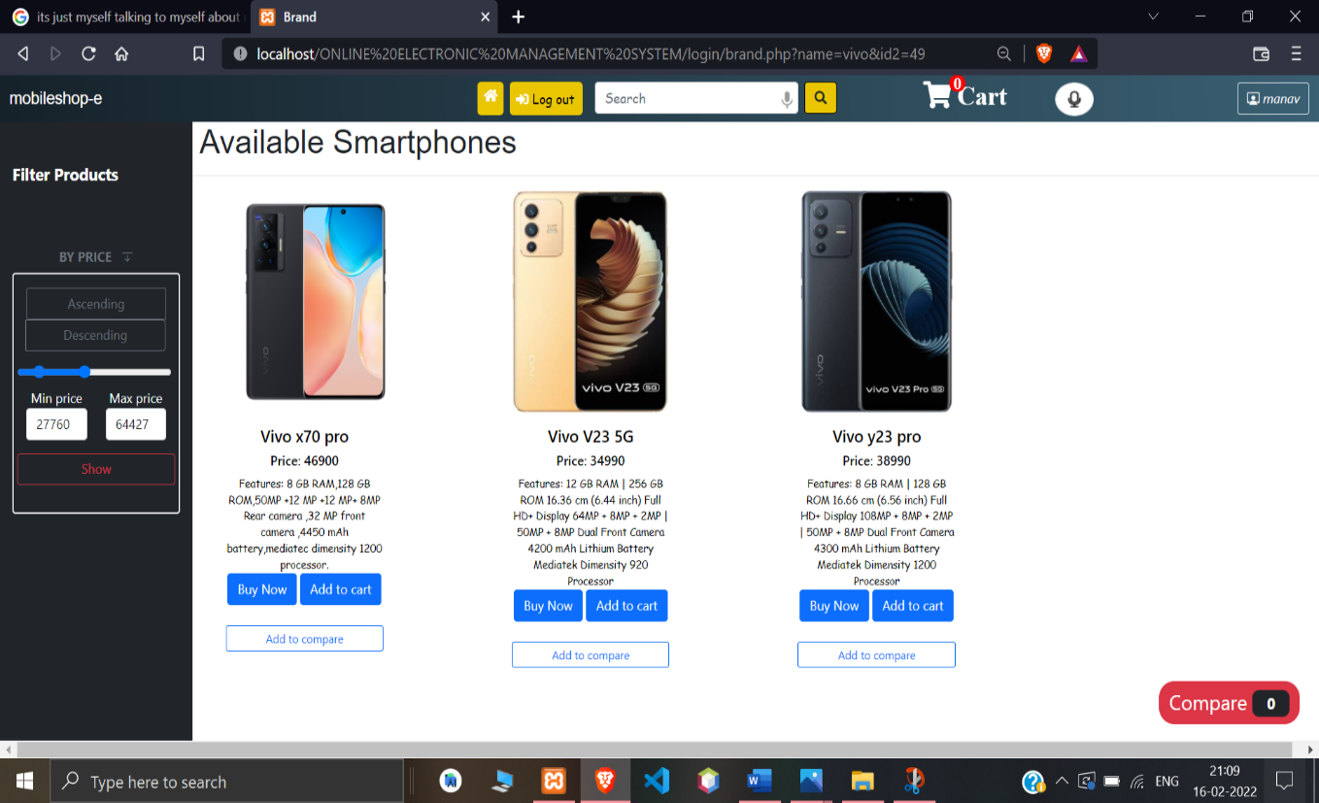

**[Figure: Filter product]**

**5.5.26 Add to cart**

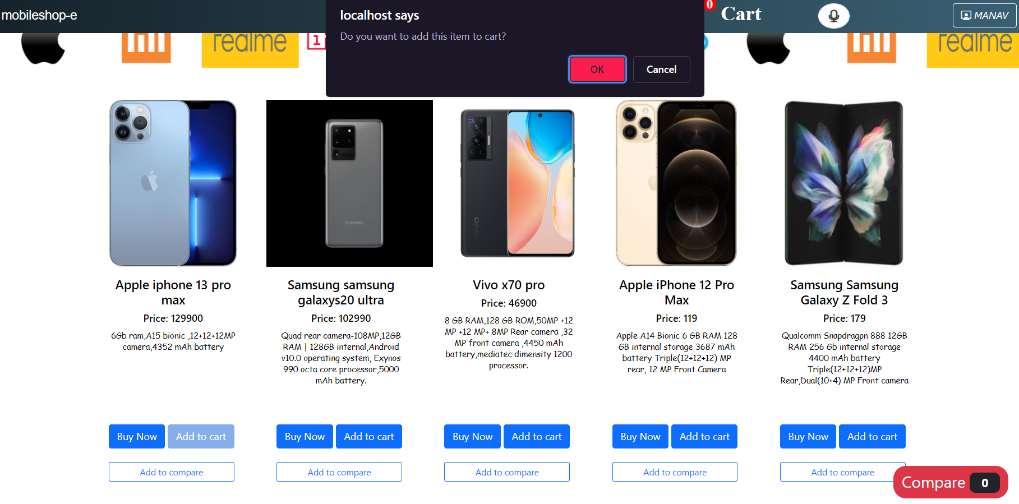

**[Figure: Add to cart]**

**5.5.27 Open cart**

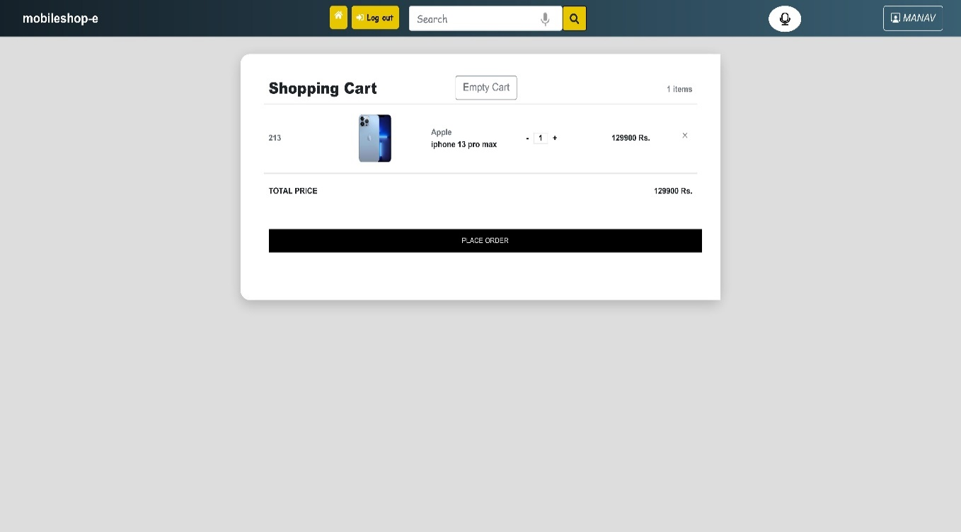

**[Figure: Open cart]**

**5.5.28 Confirm order**

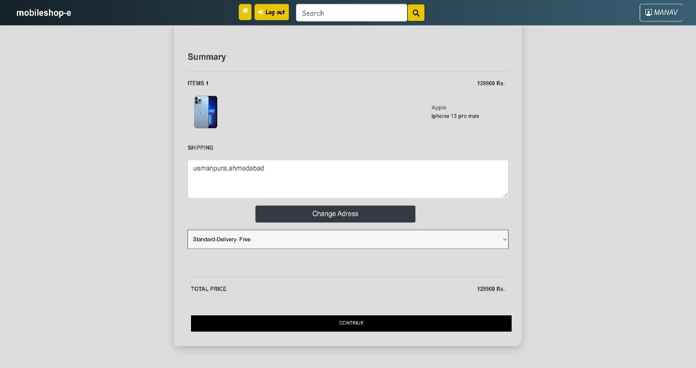

**[Figure: Confirm order]**

**5.5.29 Change address for payment**

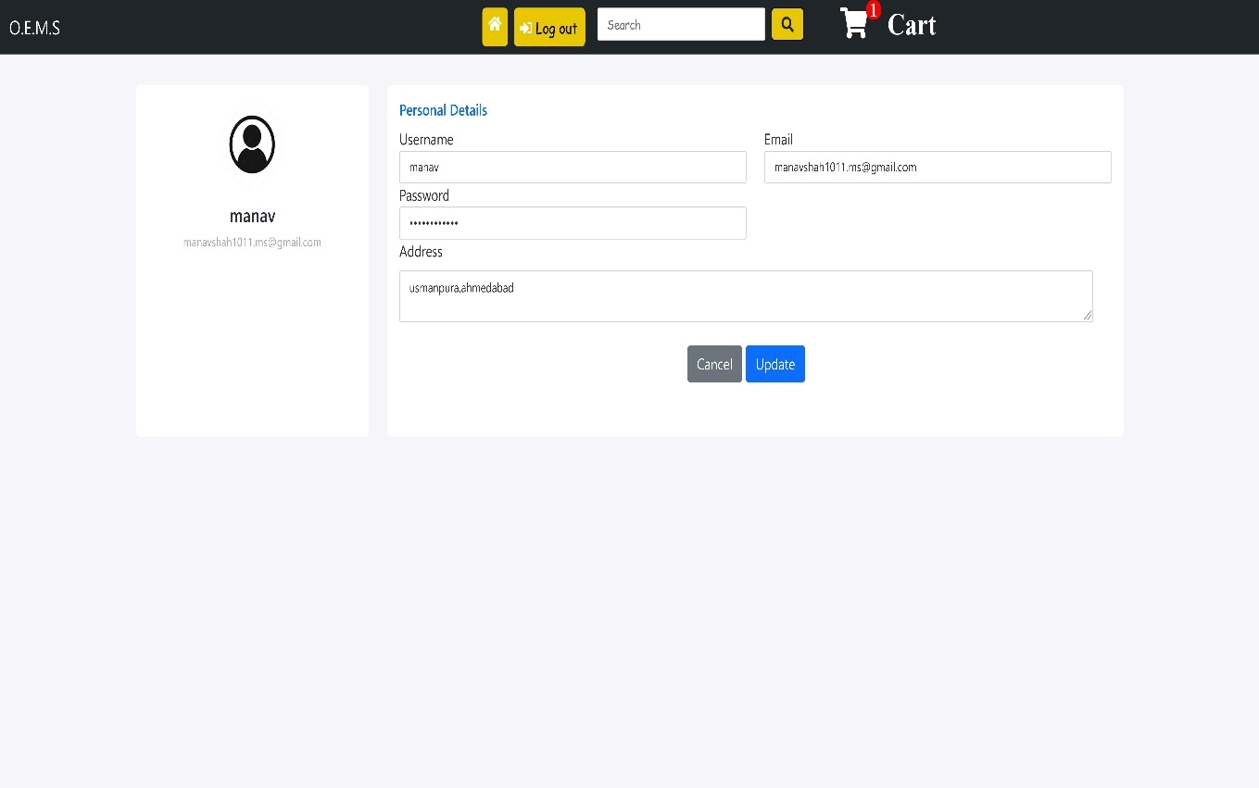

**[Figure: Change address for payment]**

**5.5.30 Place order**

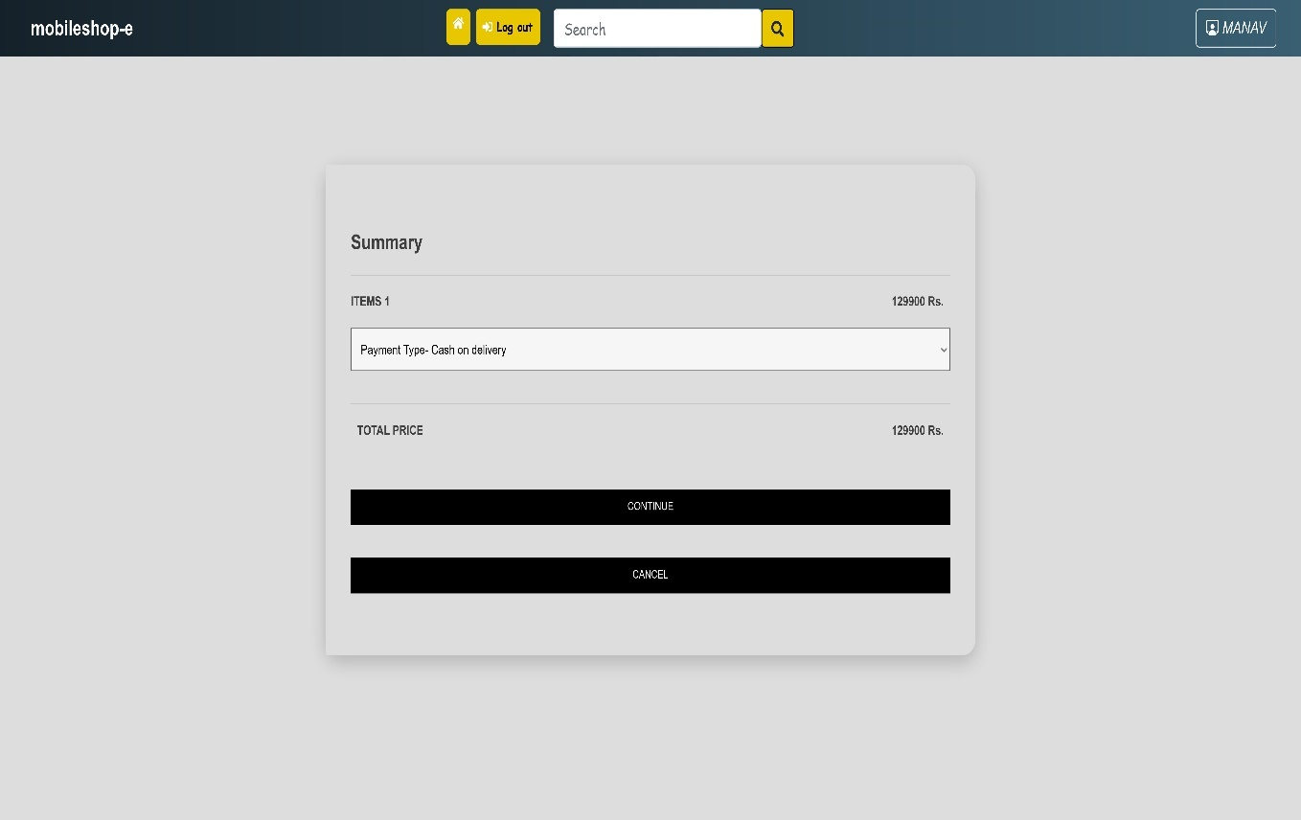

**[Figure: Place order]**

**5.5.31 Confirm payment**

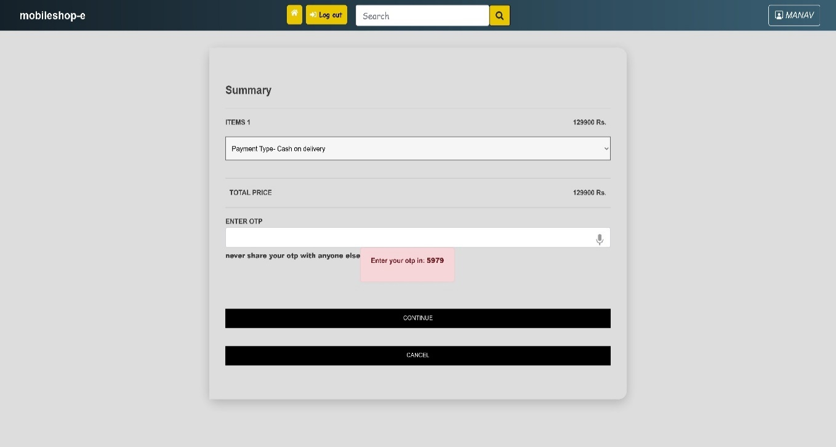

**[Figure: Confirm payment]**

**5.5.32 Enter otp for payment**

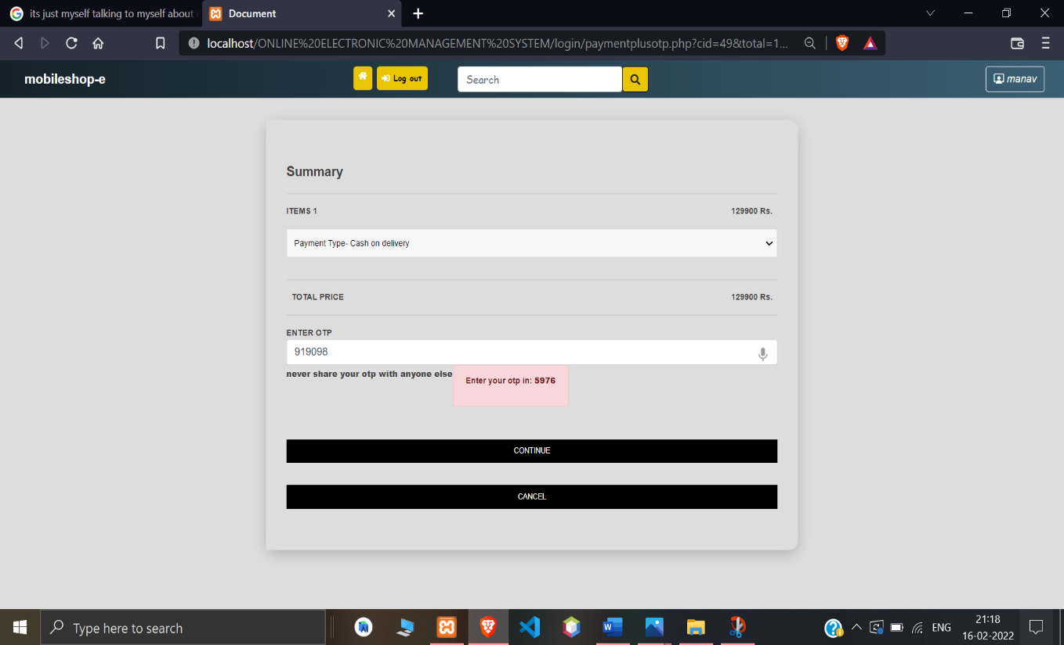

**[Figure: Enter otp for payment]**

**5.5.33 Add to compare**

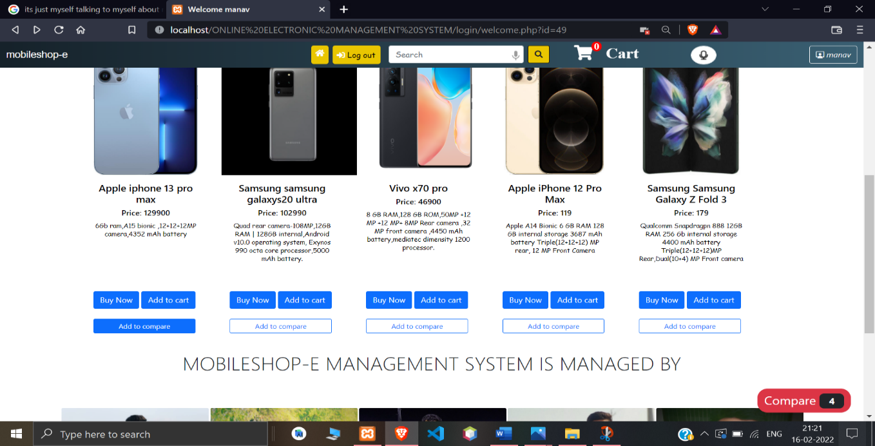

**[Figure: Add to compare]**

**5.5.34 Compare page**

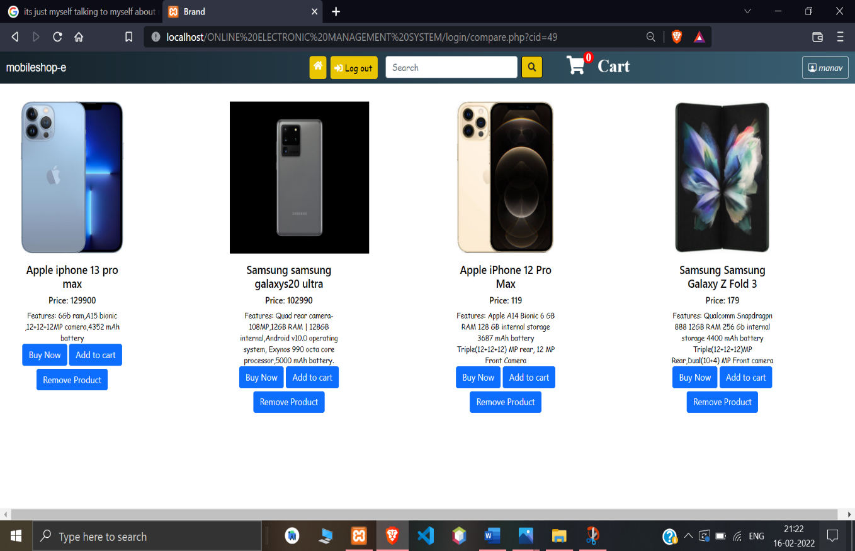

**[Figure: Compare page]**

**5.5.35 Go to my orders page**

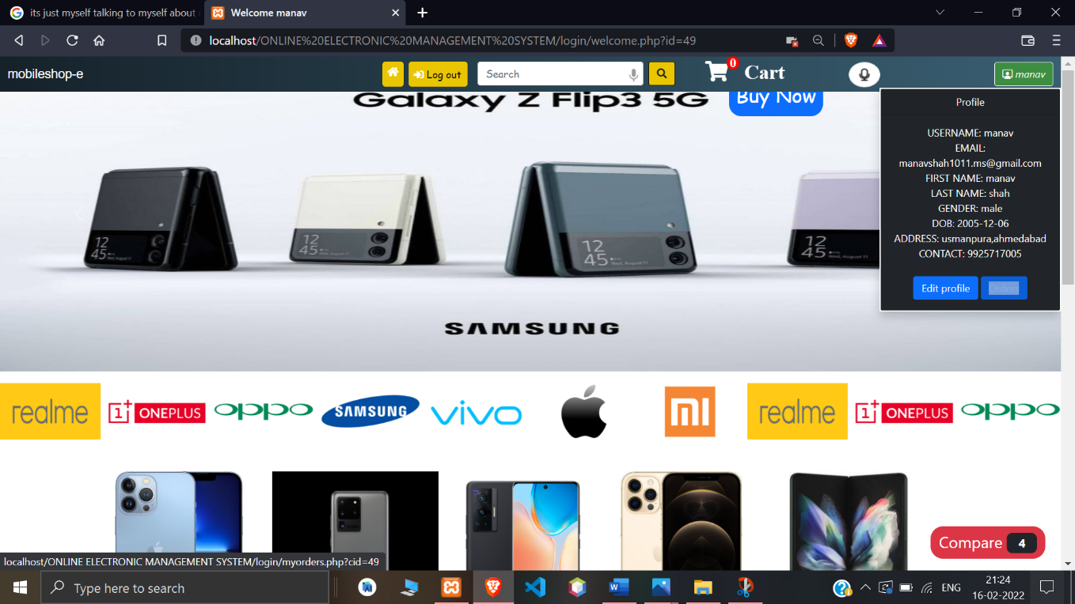

**[Figure: Go to my orders page]**

**5.5.36 Go to my orders page**

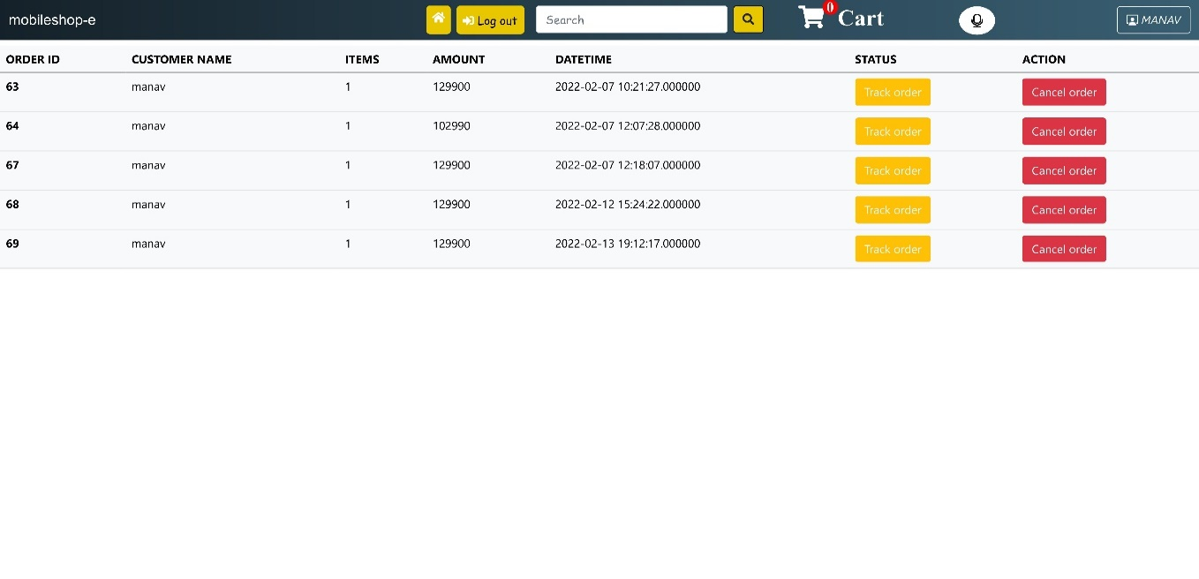

**[Figure: My orders page]**

**5.5.37 Ongoing orders**

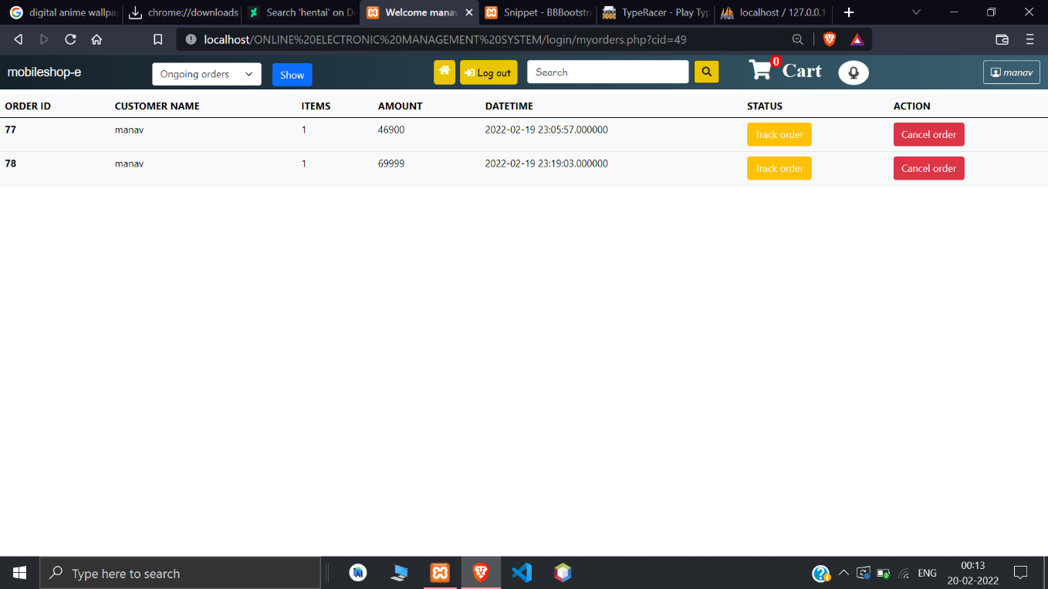

**[Figure: Ongoing orders]**

**5.5.38 Completed orders**

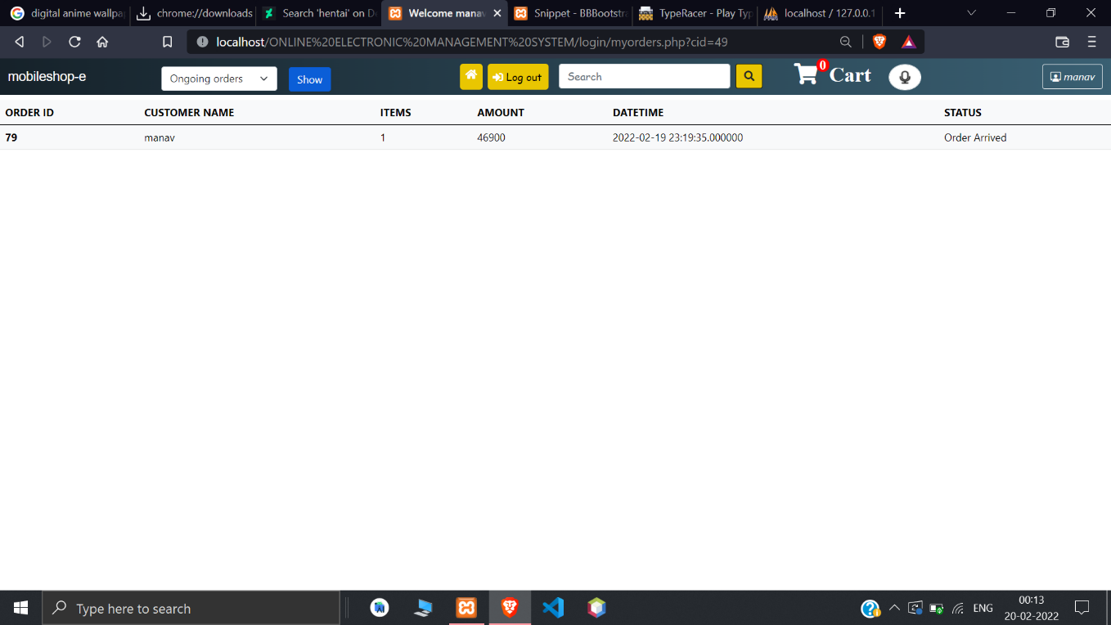

**[Figure: Completed orders]**

**5.5.39 Track order**

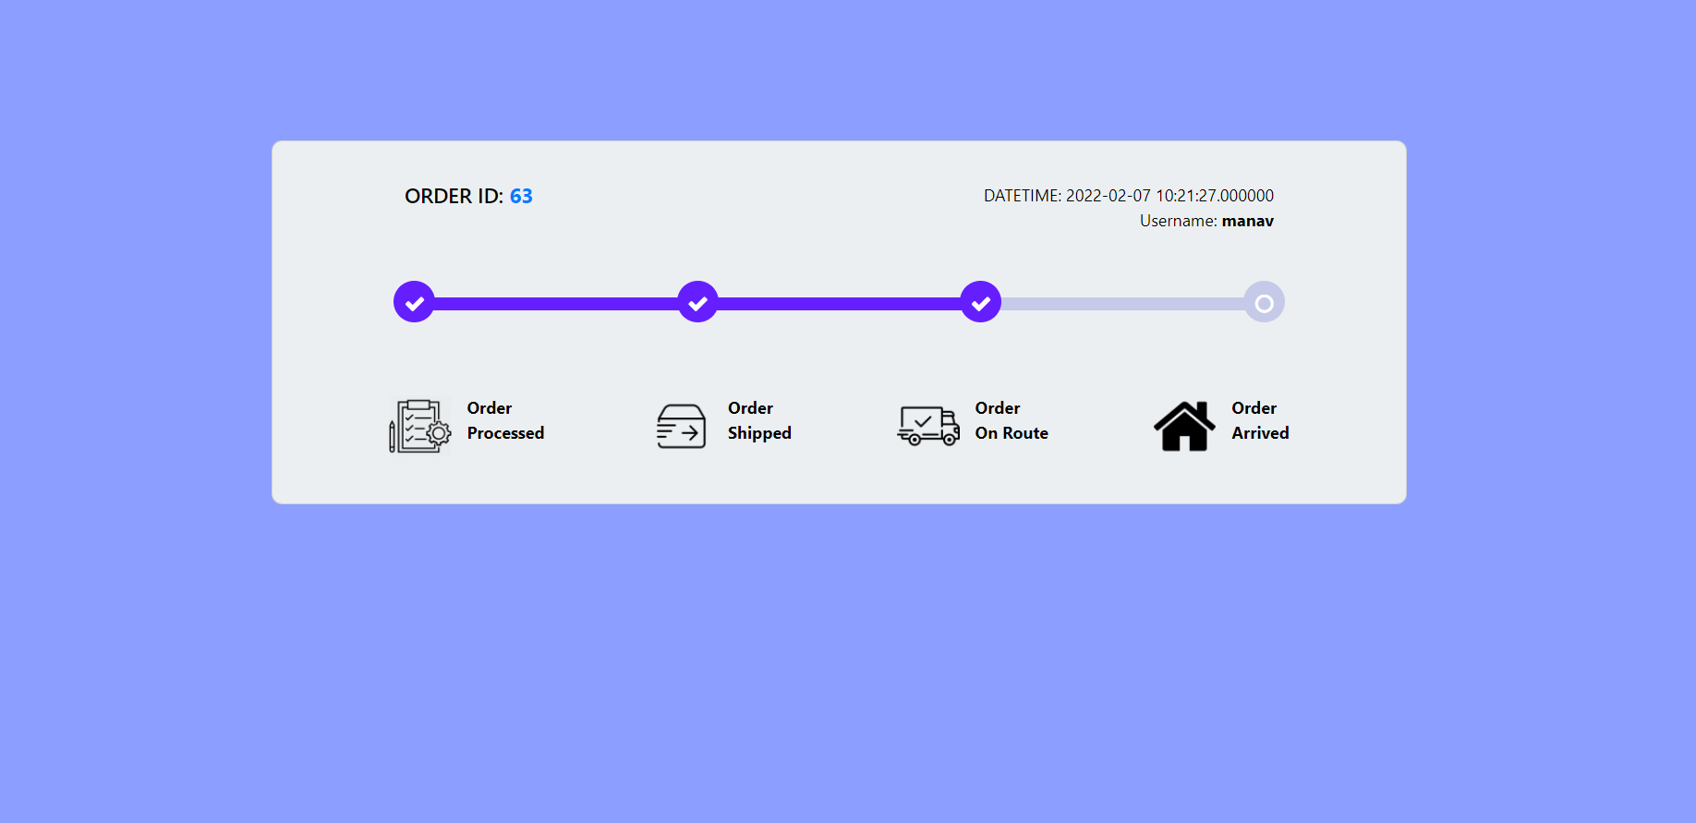

**[Figure: Track order]**

**5.5.40 Delete order**

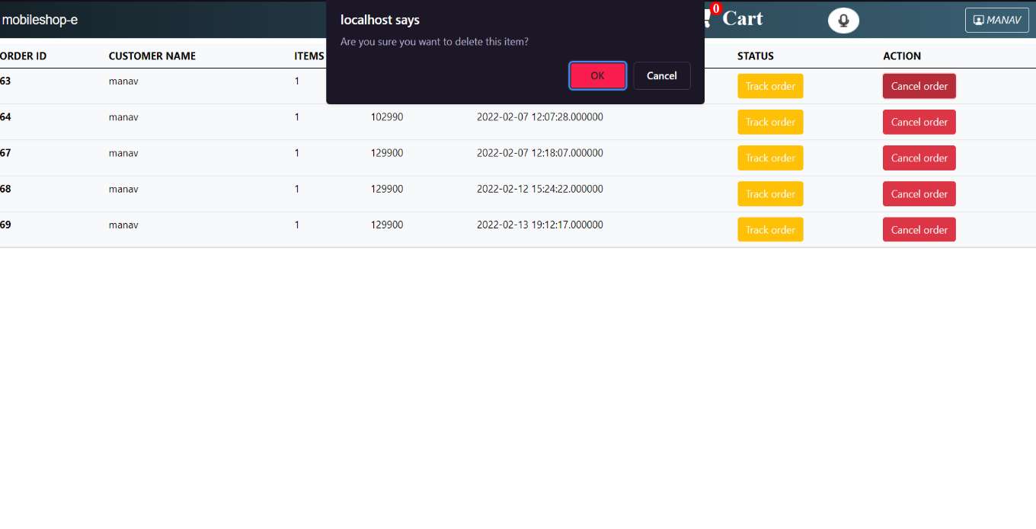

**[Figure: Delete order]**

**5.5.41 Logout for user**

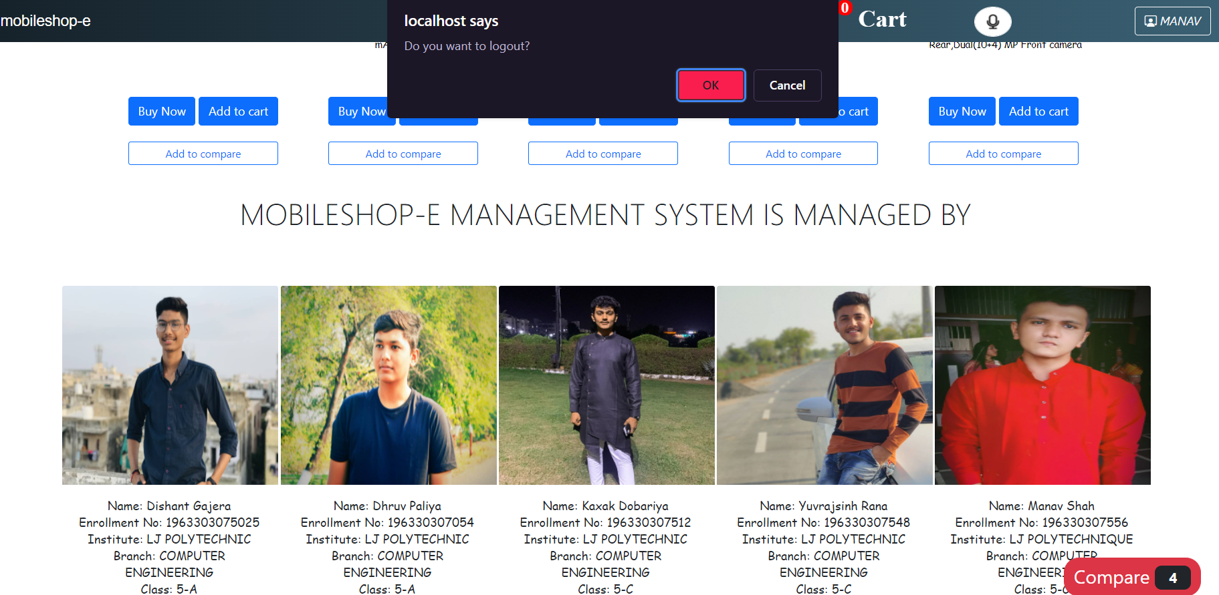

**[Figure: Logout for user]**

**5.5.42 Admin login**

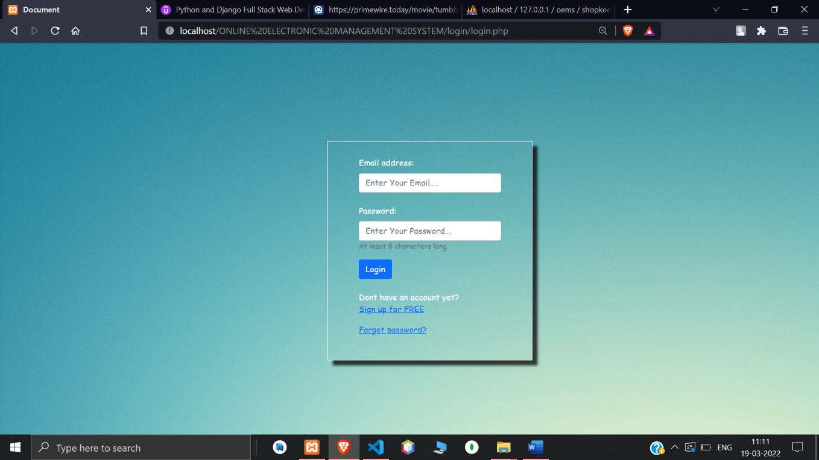

**[Figure: Admin login]**

**5.5.43 Admin home page**

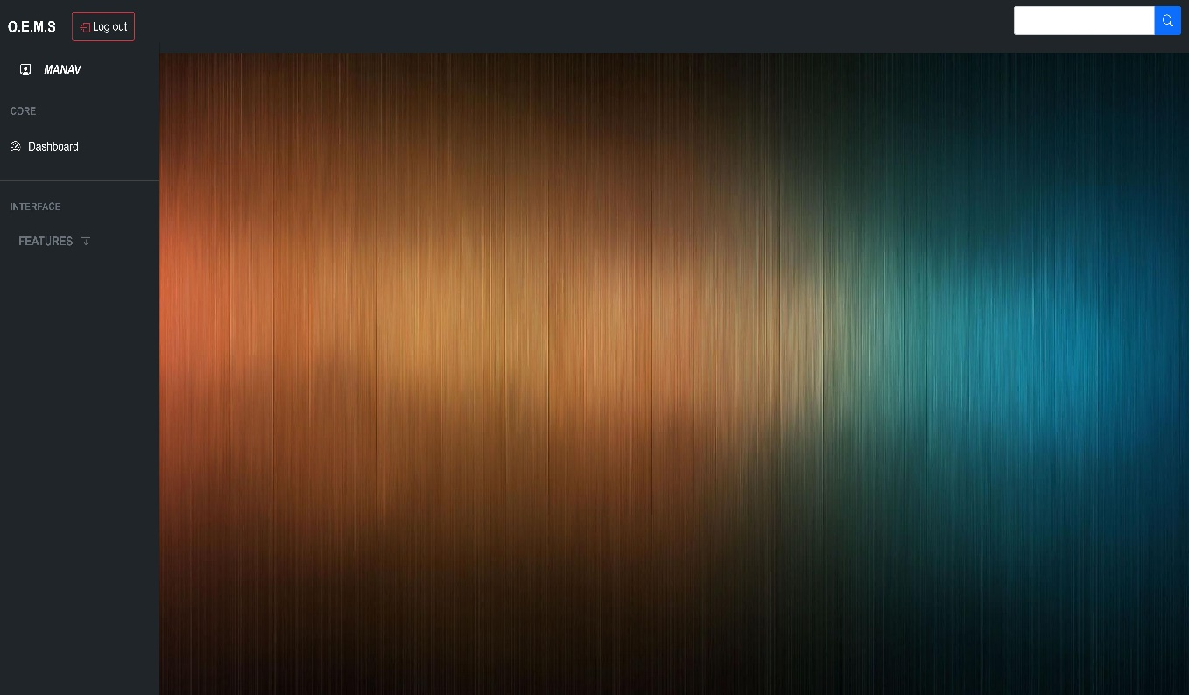

**[Figure: Admin home page]**

**5.5.44 Admin dashboard**

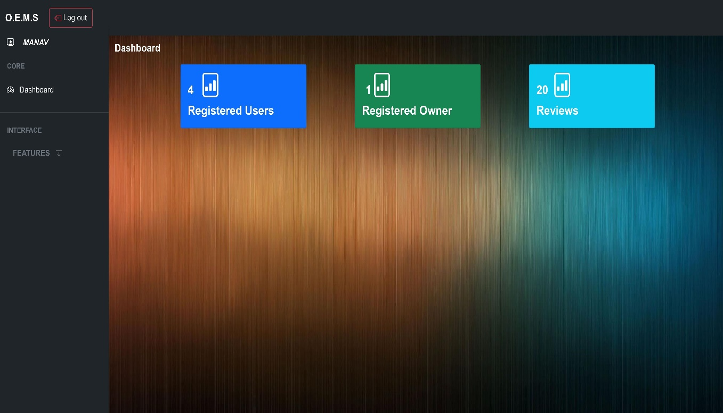

**[Figure: Admin dashboard]**

**5.5.45 Change profile**

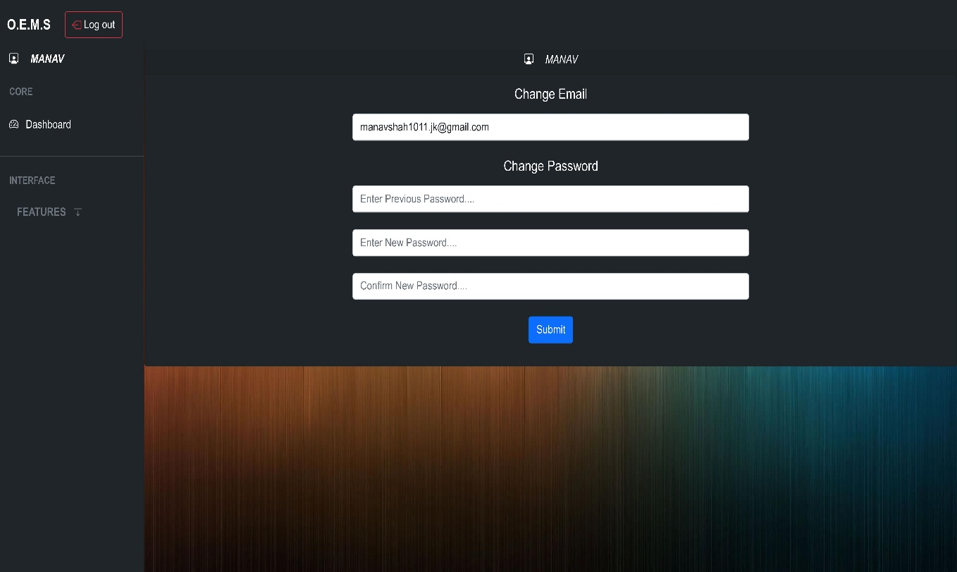

**[Figure: Change profile]**

**5.5.46 Search user**

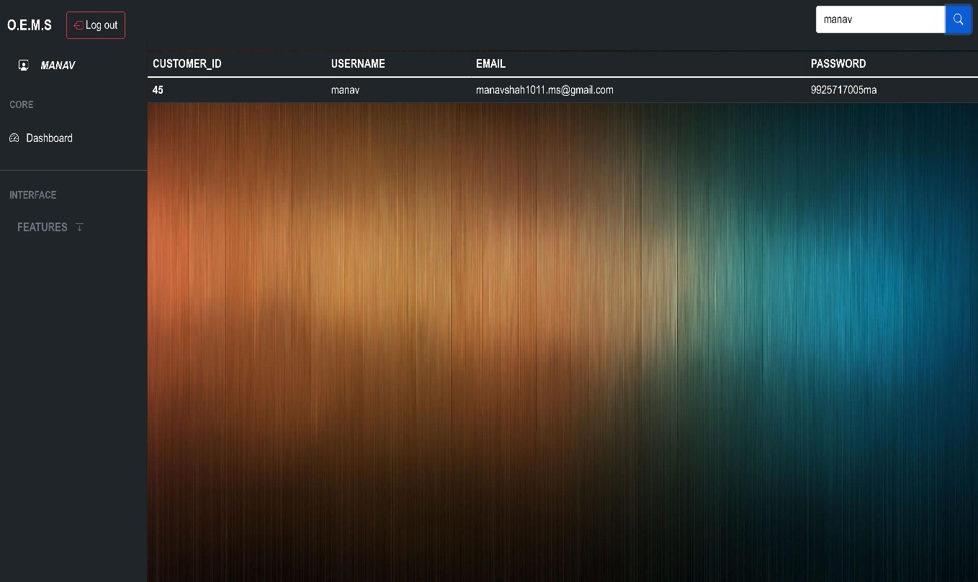

**[Figure: Search user]**

**5.5.47 View users**

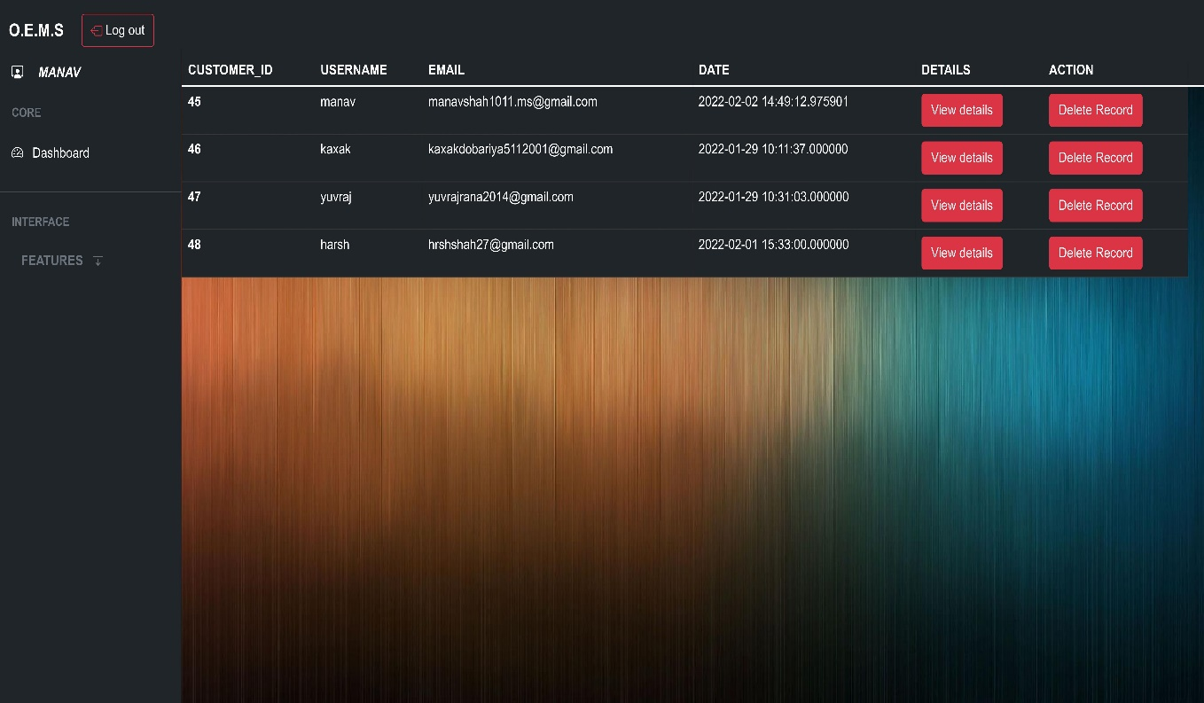

**[Figure: View users]**

**5.5.48 View shopkeeper**

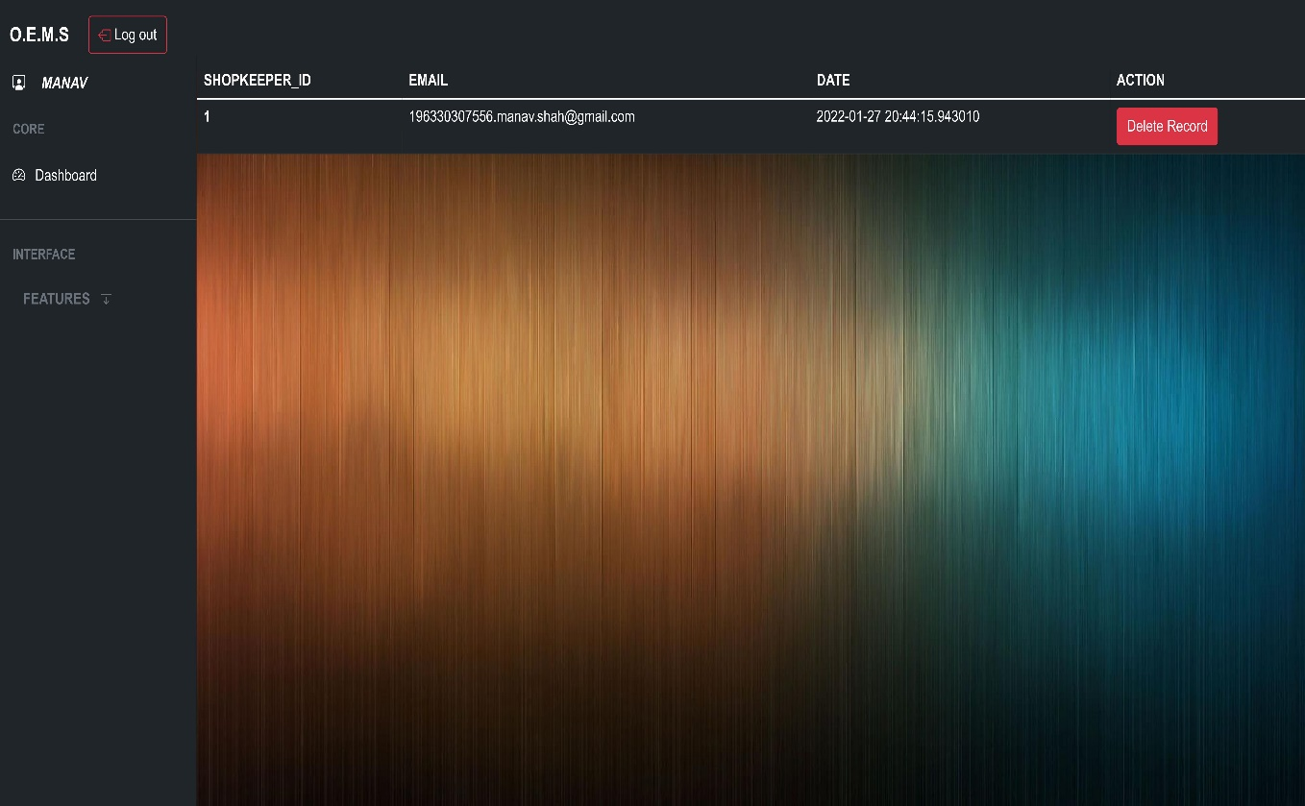

**[Figure: View shopkeeper]**

**5.5.49 Logout for admin**

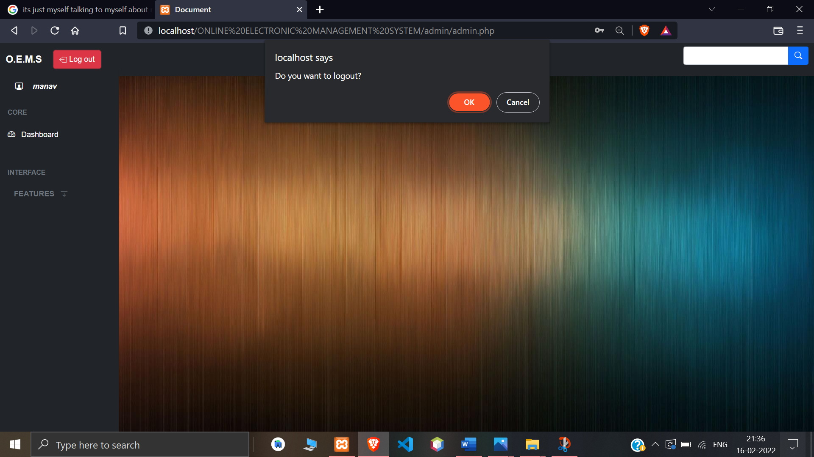

**[Figure: Logout for admin]**

**5.5.50 Shopkeeper login**



**[Figure: Shopkeeper login]**

**5.5.51 Shopkeeper home**

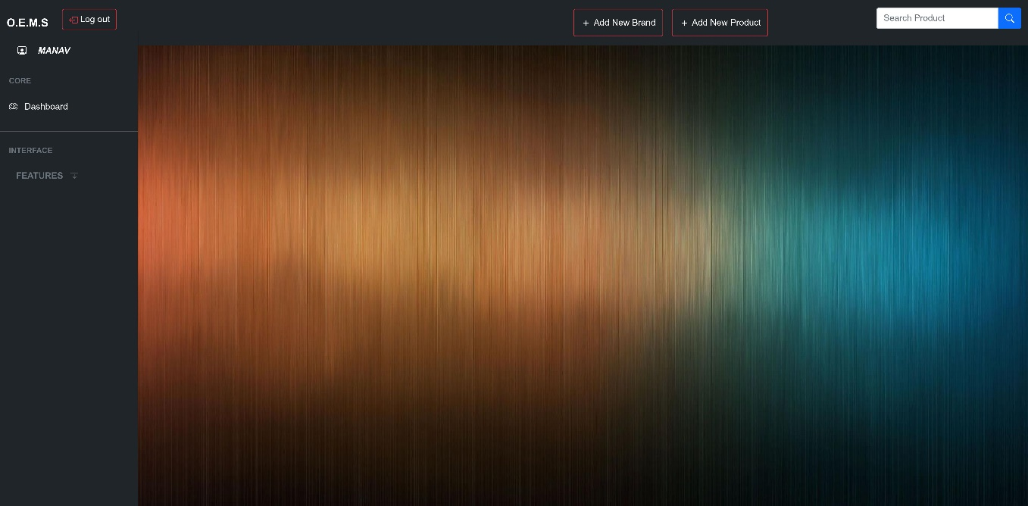

**[Figure: Shopkeeper home]**

**5.5.52 Add product**

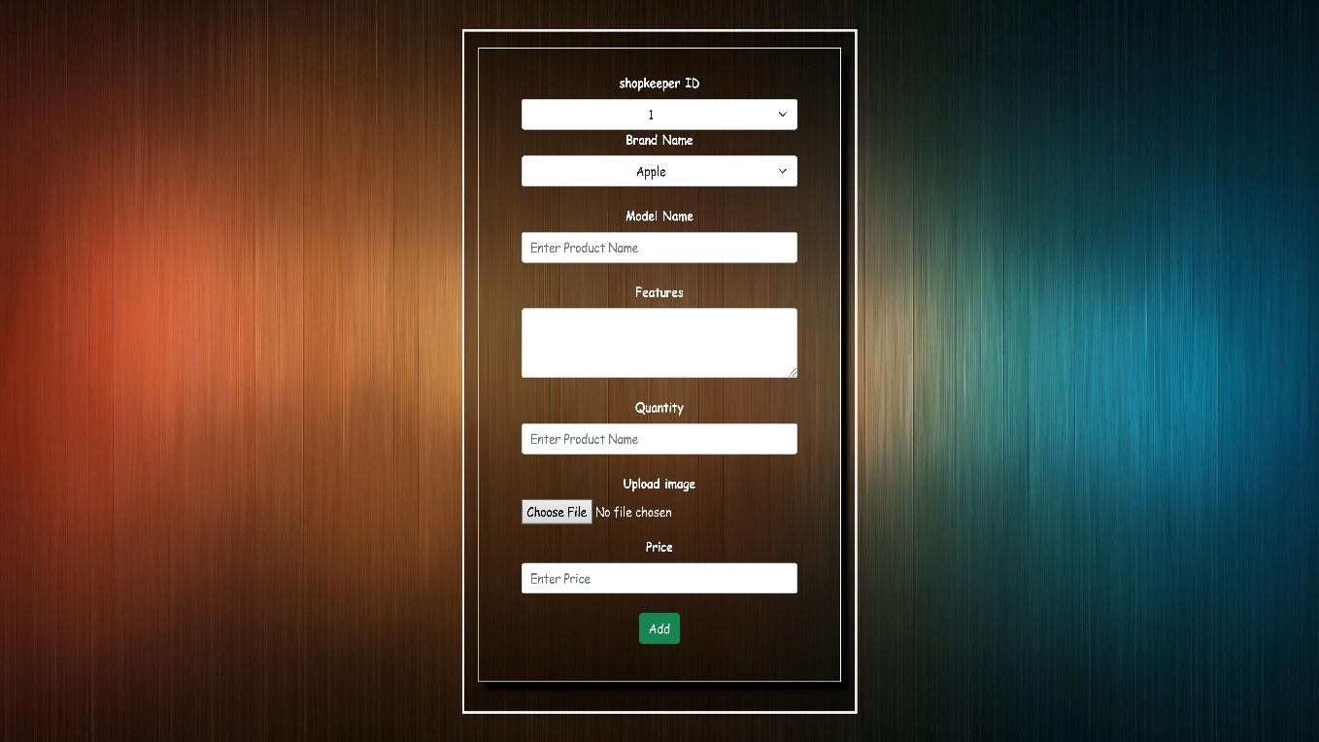

**[Figure: Add product]**

**5.5.53 Add brand**

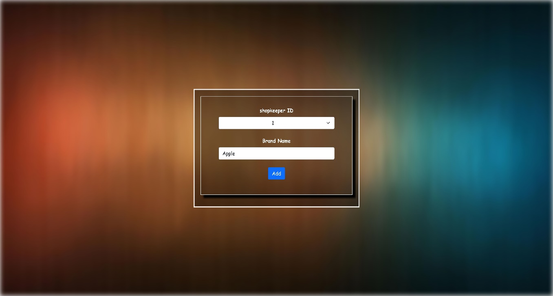

**[Figure: Add brand]**

**5.5.54 Search product**

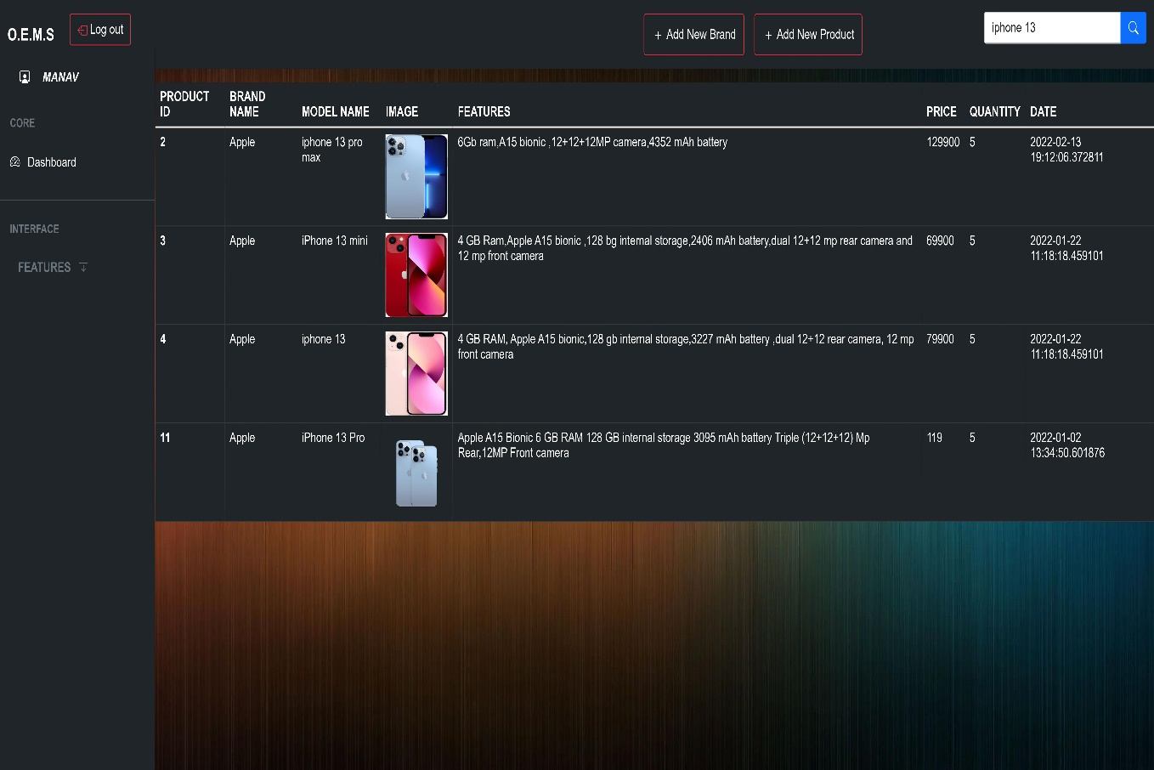

**[Figure: Search product]**

**5.5.55 Shopkeeper Dashboard**

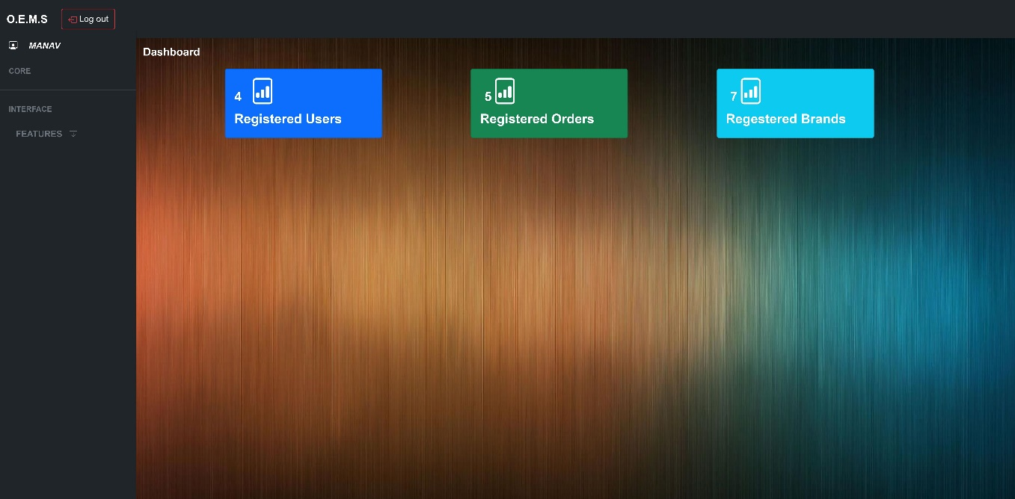

**[Figure: Shopkeeper dashboard]**

**5.5.56 Edit profile**

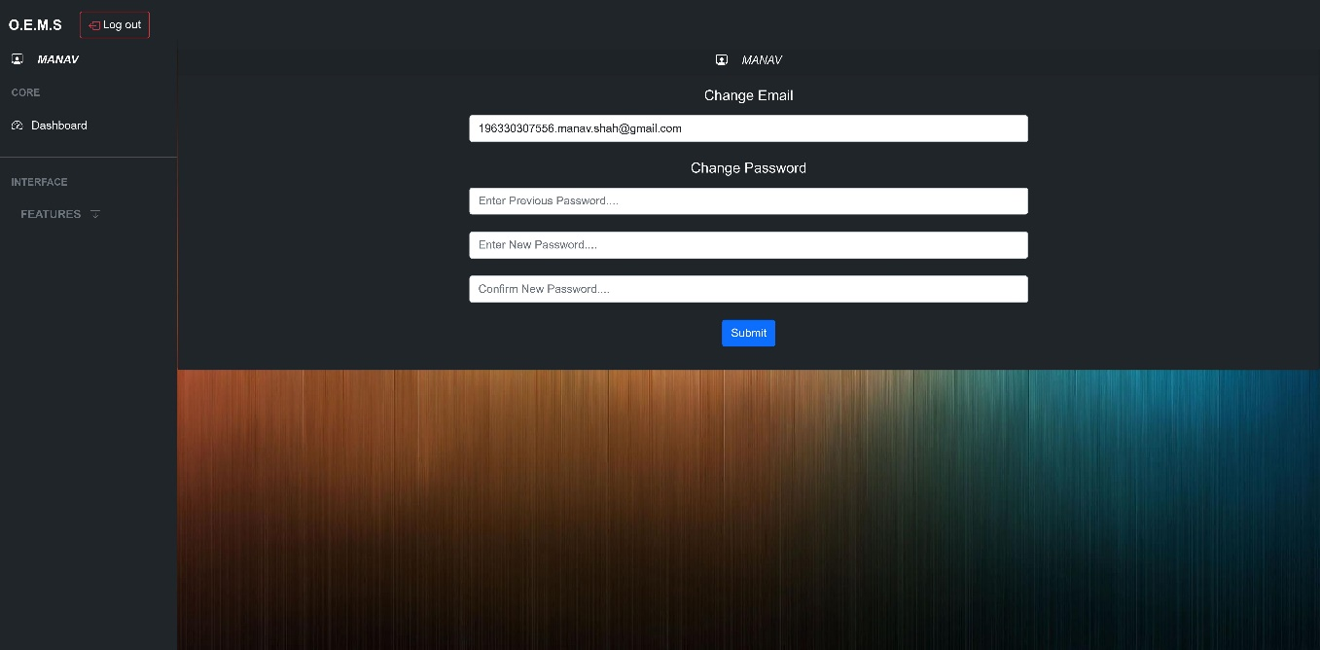

**[Figure: Edit profile]**

**5.5.57 Registered users**

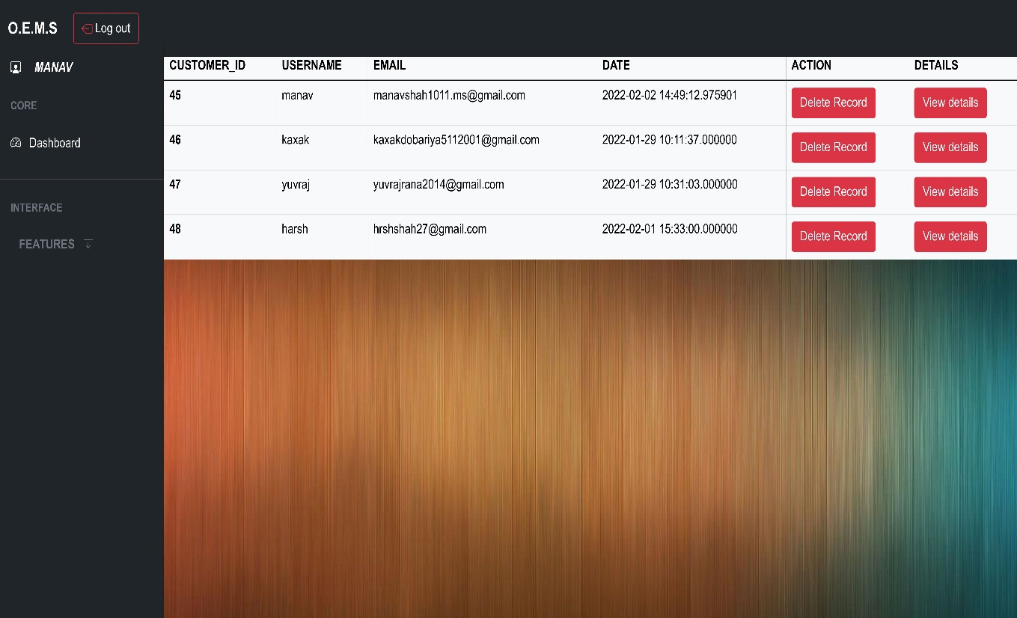

**[Figure: Registered users]**

**5.5.58 Delete user**

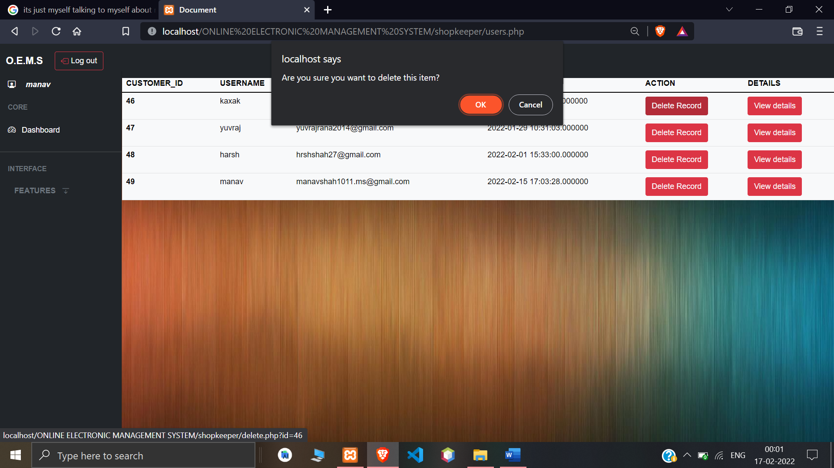

**[Figure: Delete user]**

**5.5.59 User details**

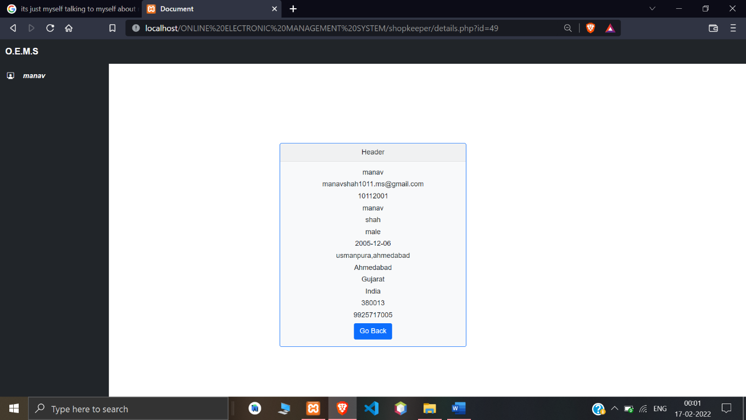

**[Figure: User details]**

**5.5.60 Registered brands**

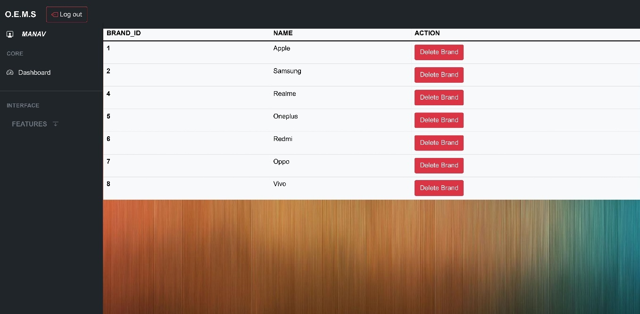

**[Figure: Registered brands]**

**5.5.61 Delete brand**

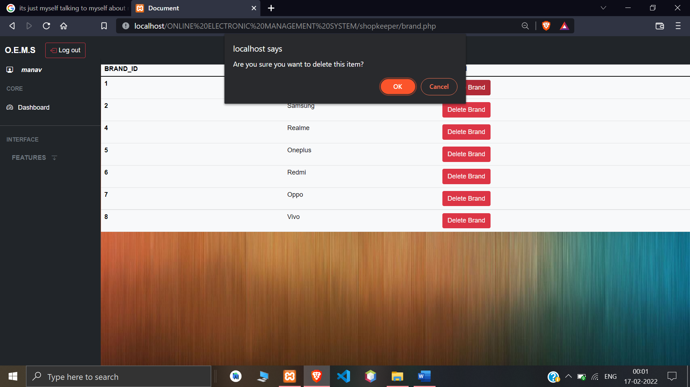

**[Figure: Delete brands]**

**5.5.62 Registered products**

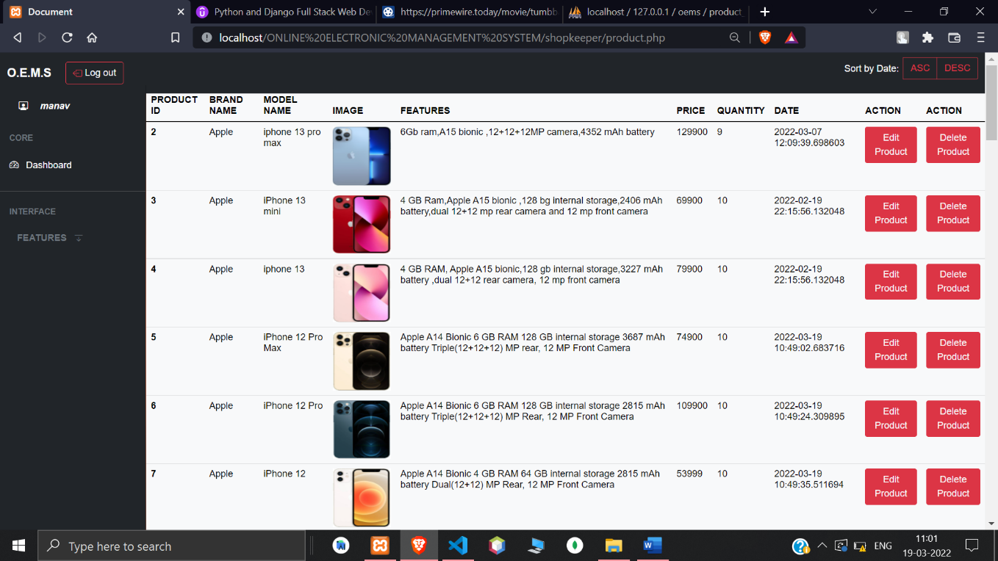**[Figure: Registered products]**

**5.5.63 Delete product**

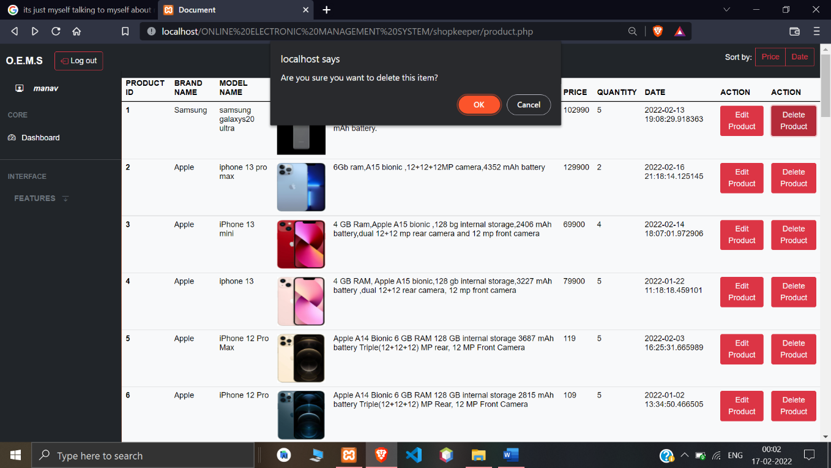

**[Figure: Delete product]**

**5.5.64 Edit products**

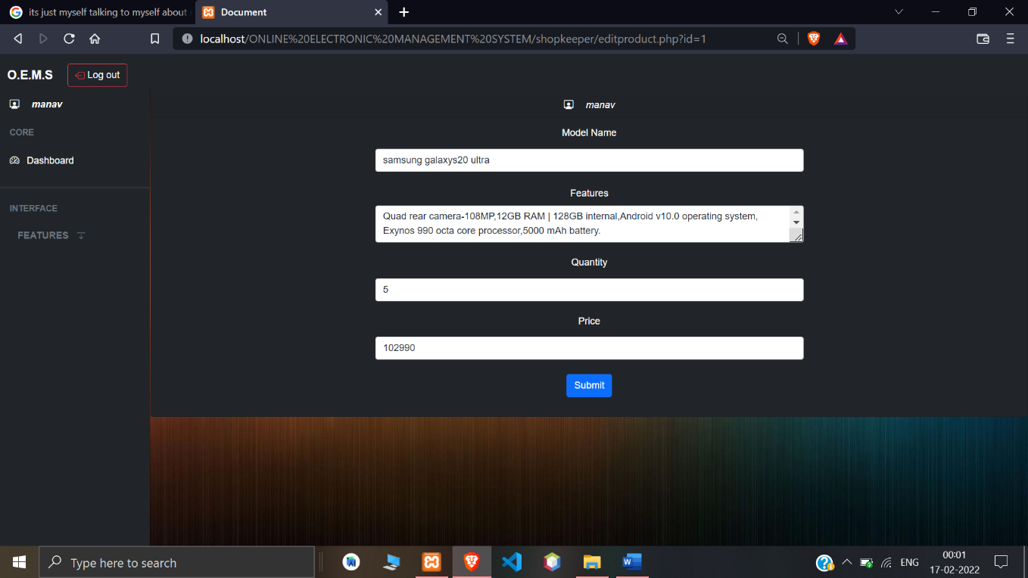

**[Figure: Edit product]**

**5.5.65 Registered orders**

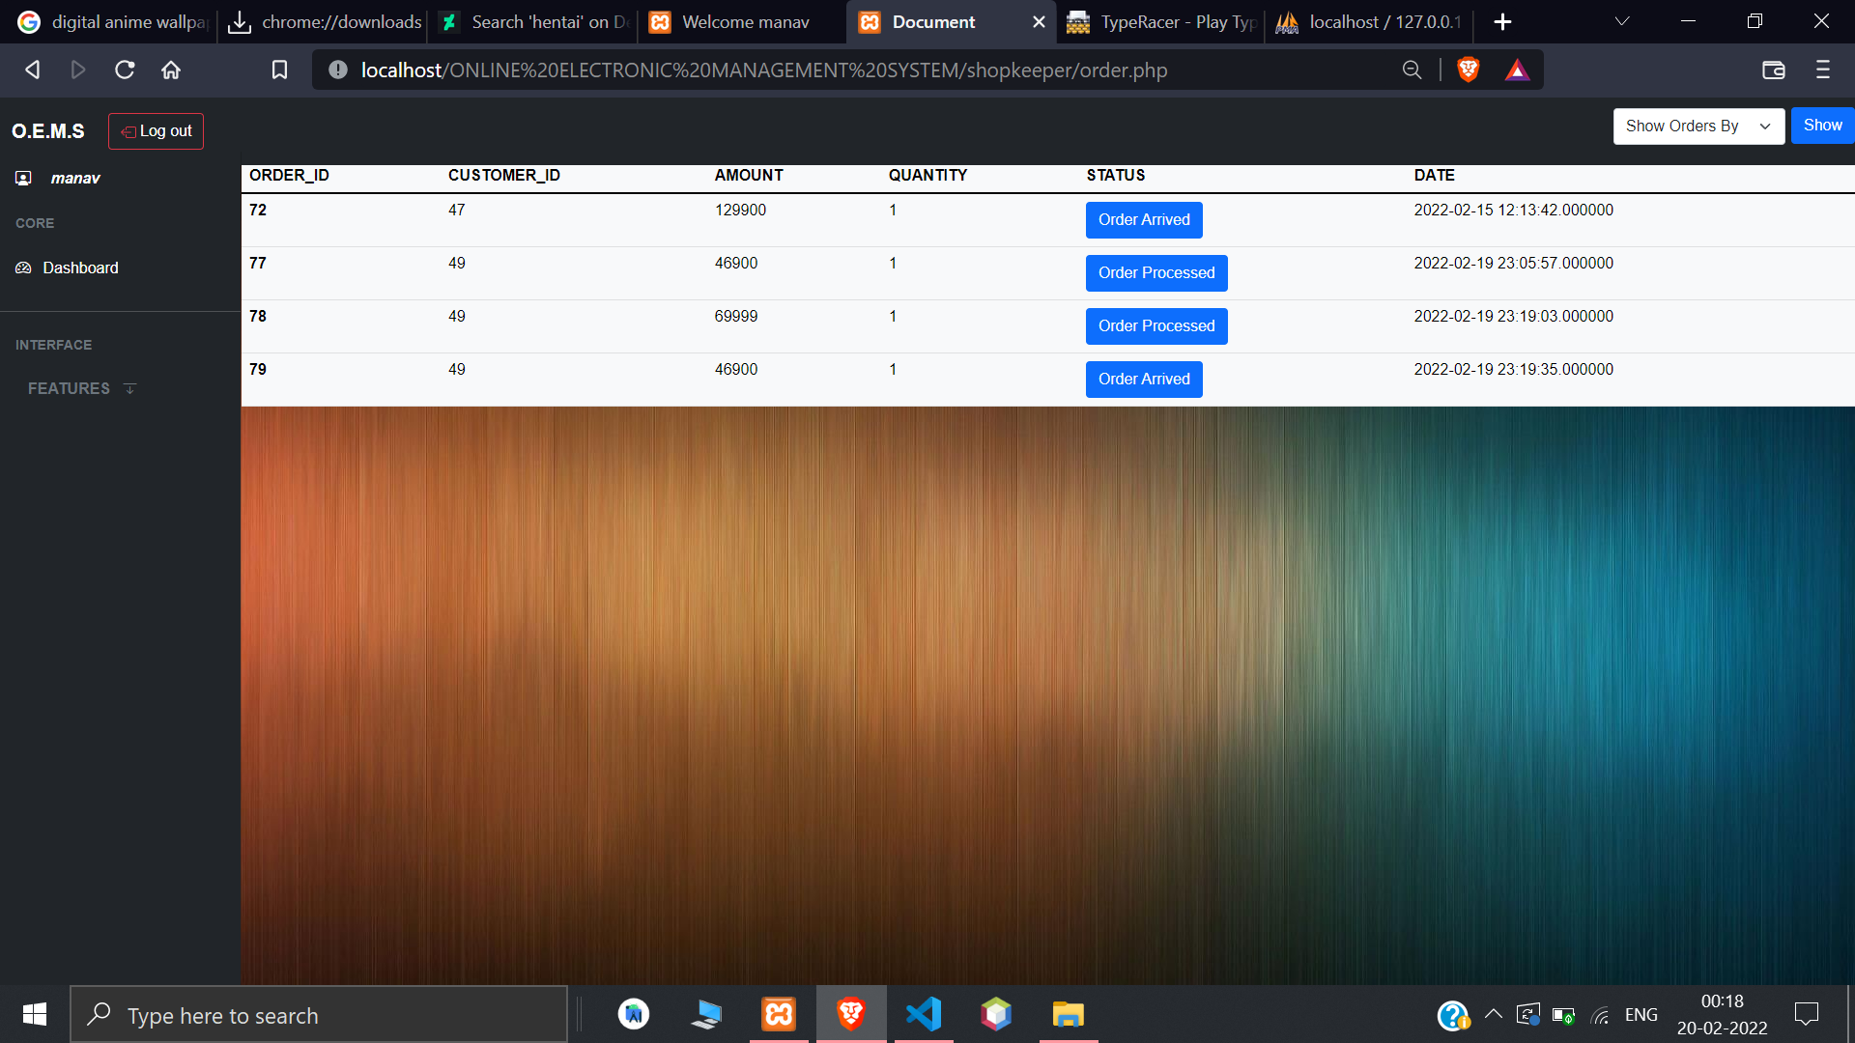

**[Figure: Registered orders]**

**5.5.66 Ongoing orders**

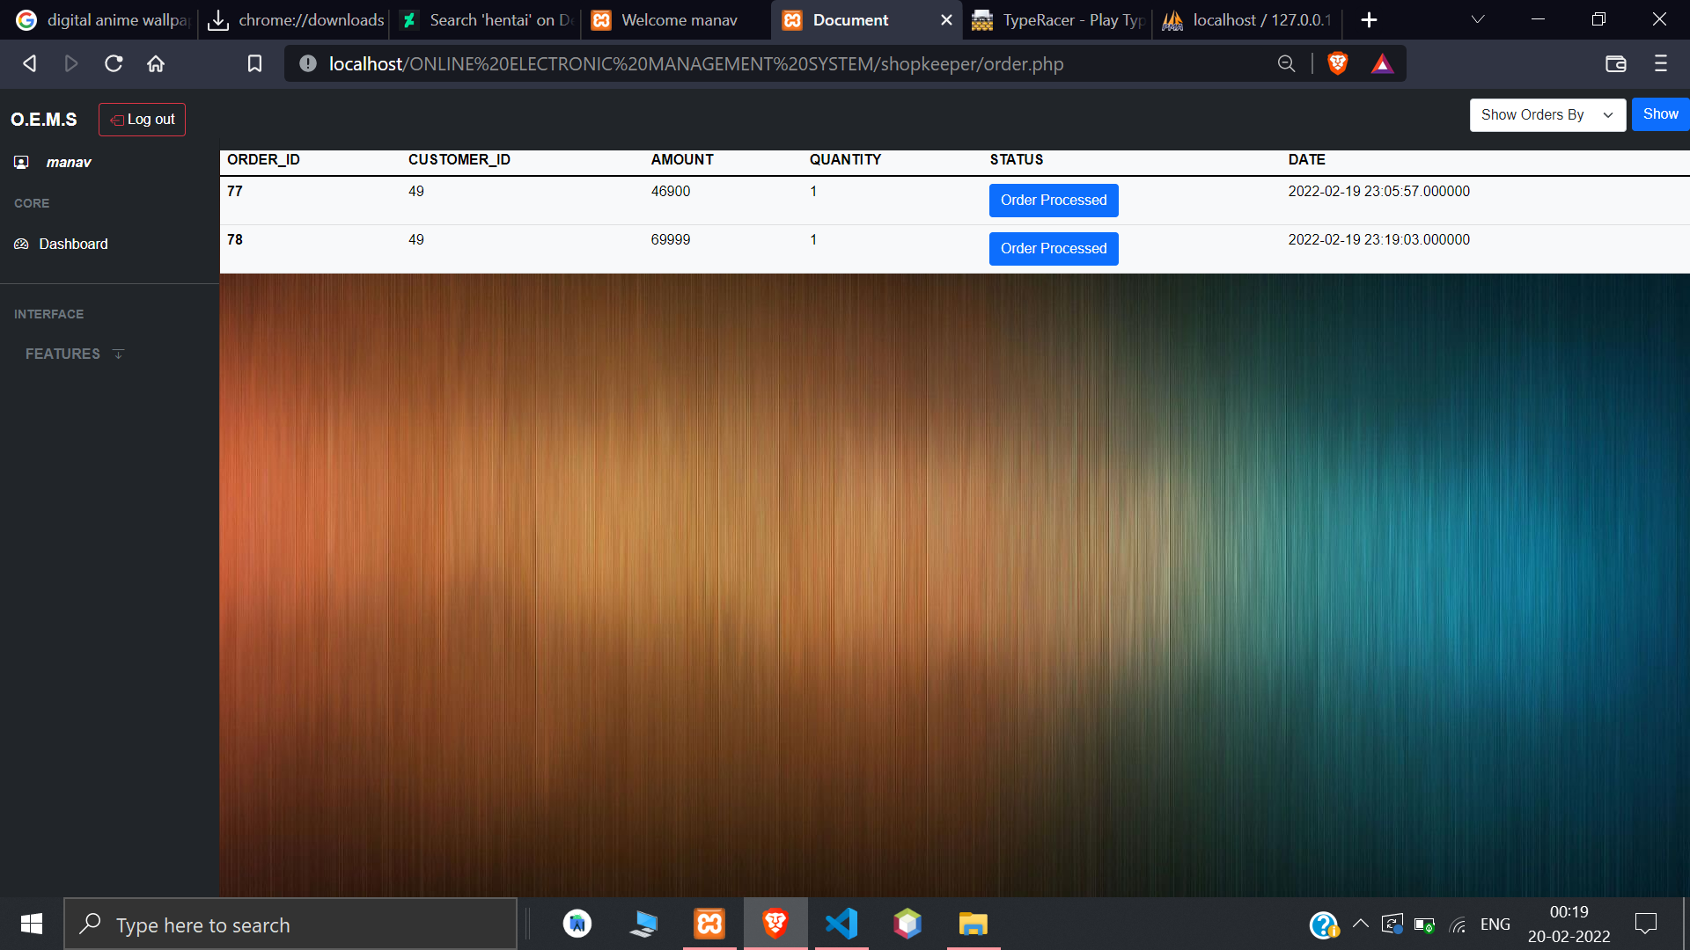

**[Figure: Ongoing orders]**

**5.5.67 Completed orders**

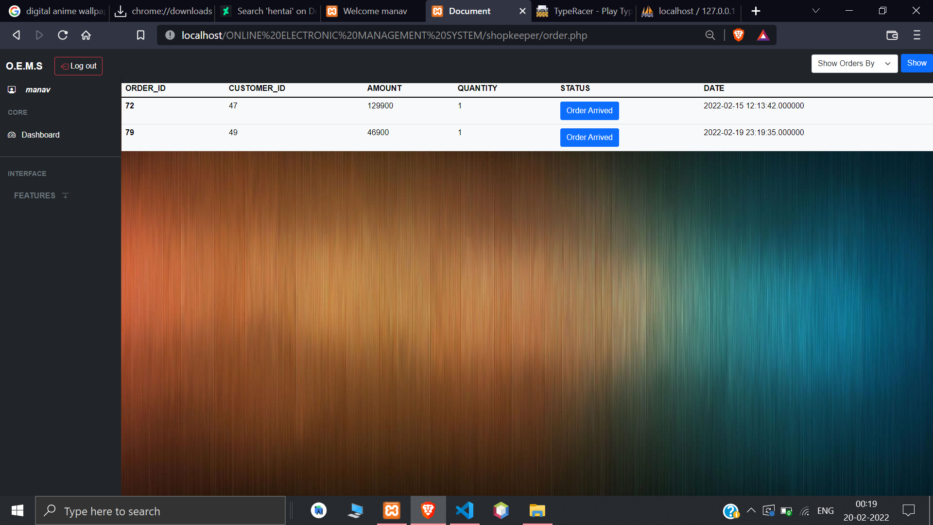

**[Figure: Completed orders]**

**5.5.68 Deleted orders**

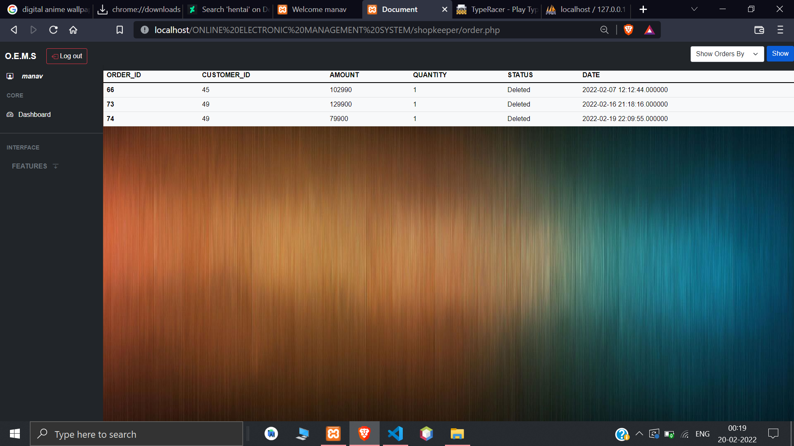

**[Figure: Deleted orders]**

**5.5.69 Change order status**

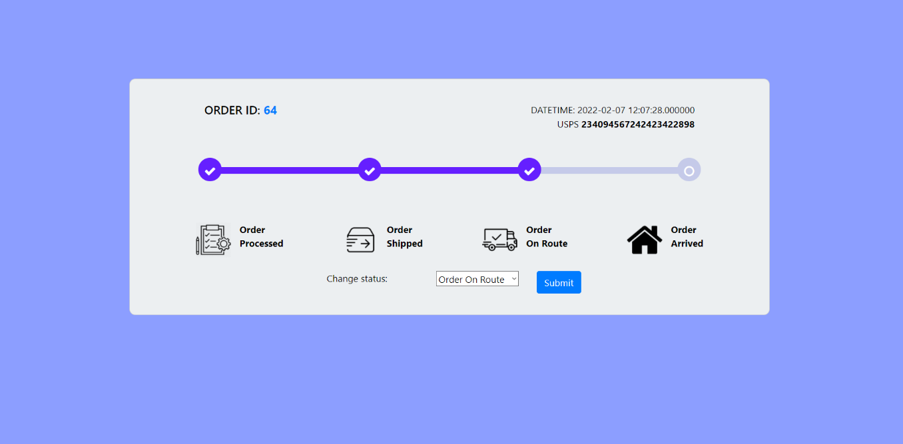

**[Figure: Change order status]**

**5.5.70 Logout for shopkeeper**

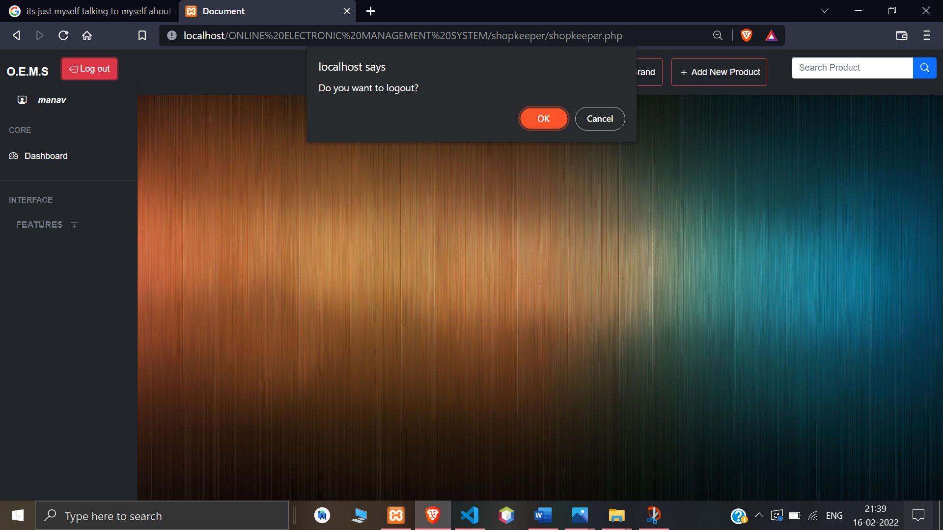

**[Figure: Logout for shopkeeper]**

**CHAPTER 6**

**TESTING**

**6.1 Testing Methods**

**6.1.1 Black Box Testing**

▪ Black Box Testing is also known as Behavioral Testing or Functional Testing. It is a technique of testing without having any knowledge of the internal working of the application.

▪ Black Box Testing treats the software as a “Black Box”- without any knowledge of internal working and it only examines the fundamental aspects of the system. This method of test can be applied to each and every level of software testing such as unit, integration, system and acceptance testing.

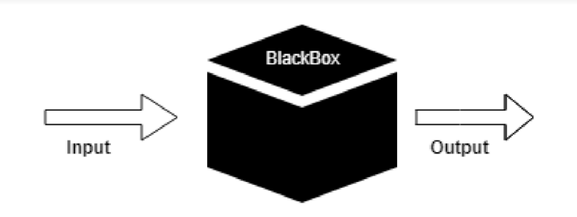

**[Figure 7: Black box testing]**

▪ This method attempts to find errors in the following cases:

• Incorrect or missing functions

• Interface Errors

• Errors in structures or external database access

• Behavior or performance errors

• Initialization and termination errors

**Advantages:**

▪ Unbiased tests because the designer and tester work independently.

▪ Tester is free from any pressure of knowledge of specific programming languages to test the reliability and functionality of an application software.

▪ Test cases can be designed immediately after the completion of specifications.

**Disadvantages:**

▪ Testing every possible input stream is not possible because it is time- consuming and this would eventually leave many program paths untested.

▪ Test cases are extremely difficult to be designed without clear and concise specifications.

▪ Results might be overestimated at time.

▪ Cannot be used for testing complex segments of code.

**6.1.2 White Box Testing**

White Box Testing is a software testing method in which the internal structure/design/implementation of the item being tested is known to the tester. The tester chooses inputs to exercise paths through the code and determines the appropriate outputs. This method is named so because the software program, in the eyes of the tester, is like a white/transparent box; inside which one clearly sees.

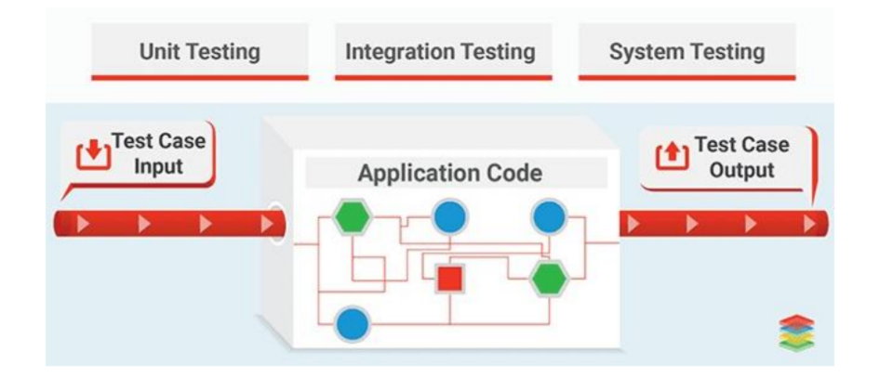

**[Figure 8: White box testing]**

▪ The aim of this testing is to investigate the internal logic and structure of the code. That is why white box testing is also known as Structural Testing.

▪ Test Cases generated using White Box Testing can:

• Guarantee that all independent paths within a module have been exercised at least once.

• Exercise all decisions whether they are true or false.

• Exercise external data structure of the program.

**Advantages:**

▪ Code optimization by revealing hidden errors.

▪ Transparency of the internal coding structure which is helpful in deriving the type of input data needed to test an application effectively.

▪ Covers all possible paths of a code thereby, empowering a software engineering team to conduct thorough application testing.

▪ Enables programmer to introspect because developers can carefully describe any new implementation.

▪ Gives engineering-based rules to stop testing an application.

**Disadvantages:**

▪ Since tests can be very complex, highly skilled resources are required with a thorough knowledge of programming and implementation.

▪ Test script maintenance can be a burden if the implementation changes too frequently.

▪ Necessity to create full range of inputs to test each path and condition make the white box testing method time-consuming.

**Example:**

In the following example, if the user enters a valid otp in 60 seconds then he will be able to reset his password but if the he enters the invalid the otp the user will be prompted to re-enter the otp.

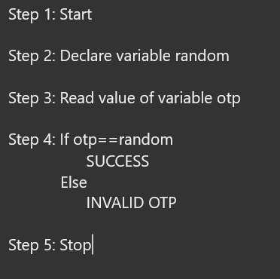

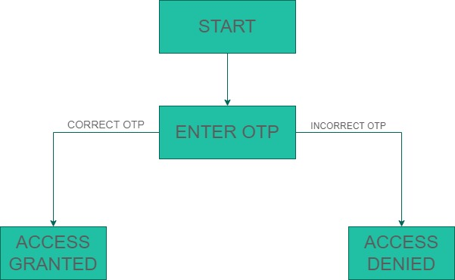

**[Figure 9: State transition diagram**

**CONCLUSION**

It was a wonderful experience to work on this project. By doing so we have learnt a lot. This project has taken us into many phases of project development and gave us a real insight of how a website of particular shop is managed online. This project will result in people being able to buy their desired products easily without walking into the shop itself.

**BILBIOGRAPHY**

* **Book References:**

1. Rajib mall “Fundamental of software engineering”, prentice hall learning India private limited. [Edition 4].
2. Jon duckett, “HTML and CSS: Design and build websites”, Wiley. [Edition 2].
3. W.Jason Gilmore, “Beginning of PHP and MySQL from novice to professional”, Apress. [Edition 4].
4. David sklar, “Learning PHP5, oreilly [edition 5].

* **Website References:**

1. “W3Schools”, [*https://www.w3schools.com/php/default.asp*](https://www.w3schools.com/php/default.asp)
2. “PHP”, [*https://www.php.net/manual/en/function.session-id.php*](https://www.php.net/manual/en/function.session-id.php)
3. “Bootstrap”, [*https://getbootstrap.com*](https://getbootstrap.com)*/docs*
4. “Geek for Geeks”, [*https://www.geeksforgeeks.org*](https://www.geeksforgeeks.org)*/php/*
5. “PHP Buddy”, [*https://www.phpbuddy.com*](https://www.phpbuddy.com)*/*
6. “JQuery CDN”, [*https://code.jquery.com*](https://code.jquery.com)*/*
7. “OWL Carousel”, [*https://owlcarousel2.github.io/OwlCarousel2/*](https://owlcarousel2.github.io/OwlCarousel2/)